Title: Waste Management and Plastic Waste in Kosovo

DEFINITIONS
Environmental policy: Laws, regulations, and policies adopted by governments at various levels to protect and preserve the environment, prevent pollution, and encourage sustainable practices.
Waste: Unwanted substances or materials of any kind, with no further use, that have completed their life cycle (e.g. worn shoes) or left after useful substances or parts have been removed (e.g. food packaging).
Illegal waste dumping: Waste materials improperly disposed of or managed, in violation of environmental regulations and laws.
Plastic waste: Discarded plastic materials that are not recycled or disposed of properly, leading to severe environmental pollution and potential threats to the biosphere.
Environmental protection: The practice of taking measures to protecting and preserving the natural environment from degradation, pollution, and damage through various measures, policies, and regulations.
Waste Management: Systematic process of collecting, processing and/or disposing of waste materials in a manner that minimizes the impact on human health and the environment.
Microplastics: Tiny plastic particles that are less than 5 mm in size. Microplastics are divided into primary and secondary categories.
Primary microplastics are those that are deliberately manufactured as a commercial product. An example of primary microplastics are the small plastic particles added in personal care products like glitter.
Secondary microplastics are small particles that originate from degradation of larger plastics objects. For example, a plastic bottle after being discarded into a landfill or in nature, driven by external factors like winds, sun and friction will break down into smaller particles.
Pollution: The introduction of harmful substances, materials or pollutants into the environment, that cause negative impacts on the ecosystem, human health, or other living organisms.
Plastic pollution: The accumulation of plastic waste in the environment and bodies of water, causing damage to ecosystems and potentially entering the food chain.
Plastic: A versatile synthetic material made from polymers, characterized by remarkable flexibility, durability, and resistance to degradation.
Plastic packaging: The use of plastic materials for the containment, protection, handling, delivery and presentation of commercial goods.
Single-use plastics: items intended to be used only once before they are thrown away or recycled, e.g. grocery bags, food packaging, bottles, etc.
Recycling of Materials and Articles: The process of converting waste materials into reusable materials that can be used to manufacture new products. This process involves the collection, sorting, decontamination, processing, and remanufacturing of materials.
Plastic recycling: The process of recovering plastic waste or residues, and reprocessing of the materials into new products, albeit often completely different in shape from their original state. This process involves actions such as: collection, sorting, decontamination, melting and remanufacturing of plastic waste into a new usable finished products. Based on the final product of each due process, the plastic recycling methodologies are classified into four stages: primary, secondary, tertiary, and quaternary.
Primary recycling: The closed loop process where recovered plastic is used in products with performance characteristics that are the same as those of the original application. A classic example of primary recycling is using discarded post-consumer PET plastic bottles in the production of new bottles.
Secondary recycling: The process that involves repurposing recovered plastic materials that have different performance requirements than the original. Secondary recycling is also called creative reuse. A classic example of secondary recycling is the production of floor tiles from plastic previously used as packaging for hygiene products.
Tertiary recycling: Advanced recycling that uses plastic waste as a raw material in a process that generates chemicals and fuels. A classic example of tertiary recycling is the process of reintroducing post-consumer PET into the production of new virgin PET.
Quaternary recycling: Energy recovery process from the incineration of plastic waste. A classic example of quaternary recycling is Tire Derived Fuels.
Reuse of products: the practice of extending the lifespan of a product (e.g. reselling used products such as clothing, footwear, tires, etc.) or repurposing a product other than its original design (e.g. using glass bottles instead of flowerpots).

RESIN IDENTIFICATION CODES
In 1988, the Society of the Plastics Industry (SPI) introduced a classification system for plastic resin with the goal to facilitate recycling of post-consumer plastics. Nowadays, plastic products are graphically marked with these codes, accordingly manufacturers are required to mark all plastic made products.
It is important to be acquainted with different categories of plastic, their uses and resin identification codes. Knowledge on this topic helps us as consumers to be more informed about our purchasing decisions that affect our health and the environment.
Code (1) PET - Polyethylene Terephthalate - water and beverage bottles, various food packaging e.g. fruit or salad containers, "take-away" food containers, rope, tote bags, winter jacket padding, carpet, fibers and fabrics etc.
Code (2) HDPE - High Density Polyethylene - bags, garbage bags, motor oil bottles, bottles/containers for hygiene products (shampoos, detergent softeners, bleach), plastic bottle caps and tetra pak, etc.
Code (3) PVC - Polyvinyl Chloride - flooring on sports courts, water pipes, plastic food wrap, some bags, tiles, window frames, sewer pipes, shoes, rain gutters, etc.
Code (4) LDPE - Low-Density Polyethylene - everyday use bags, various plastic food wraps, frozen food bags, flexible lids for boxes, condiment squeeze bottles for ketchup, mustard, etc.
Code (5) PP - Polypropylene - durable and heat-resistant plastic products such as food containers, kitchen utensils, take-away food containers, disposable cups and plates, plastic furniture, chemical bottles/containers for products like bathroom cleaners, first aid products, syringes, baby diapers, etc.
Code (6) PS - Polystyrene - egg cartons, plastic plates, all containers and packaging for food that we order from restaurants or bars, catering foam containers, bicycle helmets, refrigerators, ovens, microwaves, vacuum cleaners, air conditioners, etc.
Code (7) Miscellaneous a Catch-all - for plastic such as: acrylic glass (PMMA) a mixture of glass fibers with plastic, polycarbonate (PC) a mixture of plastic with carbon, etc. Products marked with code 7 are chiefly: baby bottles, bottle coolers, some car spare parts, nylon, CDs, mobile phones, plexiglass, airplane windows, various nut and peanut bags, frozen food bags, etc.
TABLE OF CONTENTS:

INTRODUCTION
- GENERAL METHODOLOGY
- LEGAL ANALYSIS
  - Methodology
  - Environmental Degradation Caused by Waste
  - Kosovo Waste Management Outlook
  - General Overview of the Legal Framework for Environmental Protection
    - Responsibilities of State Bodies under Kosovo’s Legal Framework
    - The Law on Waste Management
    - Kosovo Integrated Waste Management Strategy and Action Plan (2021-2030)
    - Municipal Regulations on Waste Management
  - Plastic in Kosovo
    - Kosovo's Plastic-related Legal Instruments
    - Comparative Analysis of National Practices with European and Regional Standards
- LAW MARATHON - LEXATHON
  - Methodology
  - Thematic Groups – Research on “Waste Management and Plastic Usage”
    - Recommendations of the Working Group on Monitoring Responsibilities
    - Recommendations of the Thematic Group on Enforcement Responsibilities
    - Recommendations of the Thematic Group on Preventive Responsibilities
  - Summary of Recommendations from Lexathon
- MEETING AND DISCUSSION WITH CIVIL SOCIETY ORGANIZATIONS
  - Municipal Challenges
  - The Role of Civil Society Organizations
  - Legal Infrastructure: Strengths and Weaknesses
  - Summary of Recommendations from the Meeting with CSOs
- PUBLIC PERCEPTIONS OF WASTE AND PLASTIC USAGE
  - Methodology
    - Qualitative Data Collection
  - Open Meetings with Citizens in 7 Municipalities of Kosovo: Analysis of Citizens' Perceptions, Values, Beliefs and Opinions
    - Plastic and Microplastics: What Do We Know and Is It Dangerous?
      - Microplastics
    - Challenges with Waste in Neighborhoods and Municipalities
    - The Practice of Nesting Plastic Bags: Do you Recycle or Reuse?
    - Overview of Environmental Legislation
    - Are Fines Imposed?
    - Illegal Waste, What Is It?
    - Summary of Findings
- QUESTIONNAIRE: WASTE, THORN IN THE EYE. IS IT FOR YOU AS WELL?
  - Methodology
    - Quantitative Data Collection
  - Demographic Profile of Respondents
    - Age Distribution
    - Gender Distribution
  - Data Analysis and Results from the Questionnaire
    - Citizens’ Experiences with Waste in Daily Urban Life
      - Public Perception of the Impacts of Waste on the Environment and the Performance of Responsible Institutions
    - Public Practices of Reporting, Recycling, and Reusing Waste
      - Illegal Dumping Reporting Practices
      - Recycling and Reuse Practices
    - Public Awareness: Environmental Legislation, Plastic Waste and Microplastics
      - What is Illegal Waste?
      - Where Should Illegal Dumping be Reported when Encountered?
      - What is Plastic Waste?
      - Public Awareness about Microplastics
      - How Informed Are Respondents About Environmental Legislation?
    - Public Perception and Attitudes Towards Plastic Waste and Illegal Dumping
    - Summary of Findings
- RECOMMENDATIONS

INTRODUCTION

DYVÓ is a creative platform whose mission is to empower every individual with the knowledge, tools, and resources necessary to actively participate in protecting and preserving the environment, safeguarding public health, and contributing to sustainability.

The platform focuses on mitigating human impact on the environment and, among other things, is dedicated to developing the knowledge bases, policies, and reforms needed to address pressing environmental issues, in particular those related to plastic pollution in Kosovo.

This publication is an extension of ongoing social efforts for environmental and climate justice, marking the starting point of a broader research process. The research underpinning this publication has gone through several stages of refinement. Despite changes in scope, it has consistently aimed to provide a clear understanding of the legal and regulatory landscape in Kosovo related to waste and plastic waste management. Consequently, the publication seeks to bring these insights closer to citizens, recognizing informed citizens as a prerequisite for meaningful participation in law amendments, equal access to information, and strengthened accountability.

I In compiling this research, in addition to reviewing available local and global literature, special importance has been given to civic contributions and perspectives. Civic involvement in environmental causes is essential, as the environment is shared and does not belong exclusively to any single institution or entity. This participatory approach underlines the belief that environmental protection must be a collective effort, supported by both institutions and individuals.

Lastly, we hope that this document serves not only as a record of the current unacceptable state of affairs but also as an impetus to rethink our relationship with waste, concurrently we aim to inspire policymakers, institutions, and citizens alike to take concrete steps that reduce our negative impact on the environment

- GENERAL METHODOLOGY

To gain a comprehensive understanding of the challenges related to the amount of waste in Kosovo, its management, and the implementation of legal mechanisms, this research employed a mixed-methods approach combining qualitative and quantitative techniques. The study was conducted during the months of March, April, and May 2023.

The research process was devised from outputs of various activities to capture perspectives from multiple angles in order to deliver more holistic results within the scope of subject matter. It began with an examination of Kosovo’s legal and regulatory framework, drawing on both local and European literature. To ensure citizen participation in this stage, a two-day legal analysis marathon, Lexathon, was organized so that amendments to the Kosovo’s legal structure are proposed. This event brought together young men and women, students, and professionals from the Faculty of Law and other related disciplines. Over the course of two days, participants analyzed existing legislation and proposed amendments to Kosovo’s legal framework on waste management.
In parallel, the research team conducted consultations with key institutional stakeholders, including the Deputy Minister of the Ministry of Environment, Spatial Planning and Infrastructure, representatives of the Kosovo Environmental Protection Agency, the Director of Public Services of the Municipality of Prishtina, and members of the Parliamentary Green Caucus. These meetings provided a thorough understanding of aforementioned stakeholders scope, and gave an insight into their future plans.
Another equally important component of the methodology focused on understanding citizens’ perceptions, beliefs, and concerns regarding waste and plastic pollution, as well as their views on the management role of local institutions. To this end, two instruments were applied for data collection, namely: seven (7) meetings with citizens, one (1) meeting with civil society organizations [focus groups], and a quantitative questionnaire, and the final phase, dissemination of a quantitative questionnaire. The focus groups generated in-depth and nuanced insights into participants’ beliefs and values, while the questionnaire offered a broader, statistically informed picture of public attitudes towards waste management and plastic usage. By triangulating findings of both instruments, the study achieved a more complete and reliable understanding of citizens’ perceptions and experiences vis-à-vis waste management and plastic usage.

The findings from all stages of the research were analyzed and synthesized into this publication. The ultimate aim is to provide a clear overview of the current situation in Kosovo and to propose actionable recommendations for addressing environmental challenges, with a particular emphasis on plastic waste management.

- LEGAL ANALYSIS
  - Methodology
The research on legal instruments for environmental protection was conducted by analyzing the legal documents of the Republic of Kosovo dedicated to environmental protection. The legal analysis focused on the issue of protecting the environment from waste, and in particular from plastic waste. In this regard, the basic environmental protection laws, sectoral strategies, and municipal regulations were examined, as these constitute part of the legal infrastructure that establishes the principles and rules for handling plastic waste. In addition, meetings with representatives of public institutions were conducted.
The data collected from the analysis were reviewed descriptively, with the aim of presenting a critical summary of the contents of the documents examined. Considering the current lack of available data on plastic waste in Kosovo, information from European environmental monitoring institutions was also used, in order to frame the analyzed data within an explanatory context in relation to the waste situation. Concurrently with the review of Kosovo’s environmental policies, the research also examined and summarized measures and campaigns undertaken by European states, as these have been put into practice or formalized as guiding principles for preventing waste generation in general, and plastic waste in particular.

  - Environmental Degradation Caused by Waste
Pollution and environmental degradation have remained major global concerns for several decades. The effects of environmental pollution and degradation are felt across every part of the world, with alarming consequences. According to data from the World Health Organization (WHO), environmental factors are associated with 24% of all deaths worldwide.

Although environmental problems are numerous, for the purposes of this research we focus more specifically on waste generation as a global challenge. The volume of waste generated by humans has increased massively over recent decades, a trend expected to continue in the coming years. If this trend persists, by 2050 global municipal solid waste generation is projected to increase by 70%.
On a global scale, it is estimated that by 2017 around 8,300 million metric tons (Mt) of virgin plastic had been produced. Since 2015 of this amount, approximately 6,300 million metric tons of plastic waste had already been generated, of which only about 9% was recycled, 12% incinerated, and 79% accumulated in landfills or the natural environment. If current production and waste management trends continue with the same dynamic, it is projected that approximately 12,000 million metric tons (Mt) of plastic waste will end up in landfills or the natural environment by 2050. This rising trend is further evidenced by the fact that globally in 2019, 253 million tons of plastic were generated, a quantity that had doubled compared to 2000.
More recently, with the increase in research on this issue, the list of human health risks associated with plastic waste has expanded to include the phenomenon of microplastics. Understanding their impact on human health requires further scientific work, however, studies such as one conducted in 2022 have already quantified the presence of microplastics in human organs.
Researchers have also documented the presence of microplastics in soil, air , bodies of water and food sources, pointing to yet another negative characteristic of plastics, beyond biodiversity loss.
Kosovo has made very little progress in addressing environmental degradation and the challenges expected as a result of climate change According to the Progress Report, Kosovo should pay particular attention to expanding waste collection capacities, improving recycling, addressing illegal landfills, and introducing circular economy measures to reduce waste volumes.
Albeit Kosovo has managed to partially harmonize its legal framework for waste management with European Union principles, it still faces a critical situation in terms of managing and minimizing the impacts of waste on environmental and public health. Among the challenges are the lack of capacity for integrated waste management, the absence of recycling infrastructure, widespread illegal landfills, and the lack of legal instruments or state initiatives for reducing plastic waste.

- Kosovo Waste Management Outlook
According to the Strategy of Kosovo on Waste Management (2013–2022), the consequences of poor waste management are evident in air, soil, and water quality, as well as in public health. Similarly, the Waste Management Strategy (2021–2030) reflects a critical situation within the waste management sector.
Kosovo continues to face a lack of efficient waste management. Albeit the coverage of waste collection services has increased across the territory, there is no organized system for waste separation at source or for recycling. Another major issue is the large number of illegal landfills across the whole territory of Kosovo. Moreover, while the Kosovo Agency of Statistics should provide data on the volume of plastic waste, such data are still not available. Similarly, other environmental institutions in Kosovo also lack these data.
As in most countries worldwide, per capita waste generation in Kosovo is on the rise. From 2014 to 2018, the volume of generated waste increased steadily: in 2014, 247,000 tons of waste were produced, whereas in 2018 this figure rose to 284,000 tons. The increase in waste generation has been documented across all Kosovo’s municipalities.
“The volume of municipal waste collected in Prishtina and its region in 2020 was 2.2% higher compared to 2019. Meanwhile, the total volume of municipal waste collected in other regions in 2020 was 0.5% higher compared to 2019.”
The overall increase in waste generation in Kosovo also reflects a rise in per capita plastic waste. Although such data are unavailable in Kosovo, if we take into account that 39.9% of plastic generated in Europe comes from food packaging, we can reasonably conclude that a significant portion of individuals’ waste in Kosovo consists of plastic food packaging
.
Kosovo has much work ahead in order to establish a sustainable integrated waste management system, including: increasing capacities, setting realistic targets and deadlines for implementing an efficient system, and aligning with sustainability objectives. Furthermore, the absence of an organized recycling system remains one of Kosovo’s greatest challenges, with the majority of waste ending up in landfills that are themselves not fully compliant with EU Landfill Directive requirements. Awareness campaigns and waste reduction policies remain scarce, while incentives to reduce waste generation have yet to be introduced through Kosovo’s legal framework in the form of concrete and enforceable instruments.

- General Overview of the Legal Framework for Environmental Protection
Environmental protection is nominally one of the core principles underpinning the Constitutional Order of the Republic of Kosovo. By the same token, under the Constitution of the Republic of Kosovo, public institutions are obliged to consider the impact of various factors on the environment in their decision-making processes, as well as to enable citizens to participate and influence these processes when they relate to environmental health.
A key piece of legislation governing the field of environmental protection is Law No. 03/L-025 on Environmental Protection, which establishes the basic framework and guiding principles for Kosovo’s environmental legislation. Among the key principles set out in this law are:
The principle of sustainable development – meaning the country’s development must responsibly manage resources while considering the needs of present and future generations.
Gradual harmonization of legal standards with those of the European Union – implying the adoption of European environmental standards.
The principle of prevention – all human activities must be planned and implemented with due consideration of their impacts on the environment and human health.
The “polluter pays” principle – namely, the polluter must bear the cost of compensating for the environmental damage caused by their activities.
The “user pays” principle – calls upon individuals as users of natural resources to bear the costs of running down natural capital and to restore the area to its previous state.
The principle of incentive measures – whereby the Government promotes practices and activities aimed at preventing and reducing pollution through incentives and stimulating measures.
The principle of public access to information – implies that every legal and natural person has the right to be informed about the state of the environment and to participate in decision-making.

Furthermore, the current limitations of scientific understanding cannot be used as justification for failing to take preventive measures against environmental risk or degradation in cases where potential or existing environmental impacts are looming.

In addition to this, Kosovo’s environmental protection framework is dispersed across several sector-specific laws, including: the Law on Waste; the Law on Integrated Pollution Prevention and Control, the Law on Nature Protection; the Law on Air Protection from Pollution; the Law on Waters of Kosovo; the Law on Energy Efficiency; the Law on Land Regulation; the Law on Chemicals; the Law on Environmental Strategic Assessment; Law on Special Protective Zones; and Law on National Parks.
Kosovo has also committed, through the signing of the Stabilization and Association Agreement (SAA) with the European Union, to strengthen cooperation in the field of environment and to halt further environmental degradation, with the aim of achieving sustainable development.
Under this agreement, Kosovo is also obliged to develop a climate policy, integrating climate change considerations into all sectors, and gradually aligning its legislation with the EU’s acquis on climate change.
Besides legislation, the main environmental policies are articulated in sectoral strategic documents such as: the Climate Change Strategy 2019–2028, the Climate Change Action Plan 2019–2021 (2018), the Air Quality Strategy 2013–2022, and the Strategy (2021–2030) and Action Plan (2021–2023) for Integrated Waste Management in Kosovo (2021). Albeit these strategies were drafted in line with circular economy principles, their implementation has been minimal.
Kosovo is signatory of the Declaration on the Green Agenda for the Western Balkans, committing to align with EU Climate Law in pursuit of 2050 carbon reduction targets. However, Kosovo has made limited progress in energy, environment, and climate change. The European Commission’s Progress Report notes that there has been no substantial progress in environmental protection. While the legal framework is partially aligned with the EU’s acquis, further work is required, particularly regarding extended producer responsibility (EPR) and the polluter pays principle

- Responsibilities of State Bodies under Kosovo’s Legal Framework
The Government is responsible for adopting secondary legislation in order to achieve the objectives and fully implement the legal framework for environmental protection. It is also responsible for adapting the Legal Framework to the European Union acquis towards a sustainable circular economy, as well as for taking actions to reduce the impact of climate change in the country.
The Ministry of Environment and Spatial Planning plays a key role in environmental protection. It is responsible for drafting and implementing environmental policies, laws and regulations. The Ministry is also responsible for monitoring and inspecting the implementation of the environmental legal framework. In addition, it coordinates activities for the implementation of environmental international agreements and acts as Kosovo’s representative in international environmental negotiations. Furthermore, on an annual basis Ministry must devise a report on the state of the environment, to be reviewed by the Government.

The Ministry of Economic Development is responsible authority for regulating the procedures for the appointment of public enterprises and due monitoring, whereas other ministries are responsible for respective sector generated waste, such as the Ministry of Health, that should be committed to ensuring mechanisms for the safe management of health-care waste.
Municipalities hold key responsibilities in the field of environmental protection. According to the Law on Environmental Protection, municipalities are required to adopt Local Environmental Action Plans (LEAPs) and environmental programs, which serve as guiding documents for the development of municipal activities in relation to the environment. Municipal environmental action plans must be aligned with the Kosovo Environmental Action Plan (KEAP). Furthermore, under applicable legislation, municipalities are required to report to the Ministry of Environment and Spatial Planning (MESP) on these plans and their implementation.
With regard to waste management, municipalities in the Republic of Kosovo are responsible for both developing the waste management legal framework and ensuring the administration and management of waste. Municipal authorities are also tasked with facilitating the necessary infrastructure for waste recycling and disposal.
The Kosovo Environmental Protection Agency (KEPA) is mandated to monitor environmental quality and is responsible for providing data to the Government, the Assembly of Kosovo, and citizens on the state of the environment. KEPA also oversees the monitoring of environmental conditions through a standardized data generation system and is obliged to produce regular reports on the general state of the environment, as well as on respective sectors.

- The Law on Waste Management
Waste management in Kosovo is regulated by a specific law, as stipulated in Article 17 of the Law on Environmental Protection. The Law on Waste No. 04/L-060 is the primary legal instrument defining principles, roles, responsibilities of different actors, and the waste management hierarchy of priorities.The main principles underpinning this law are: sustainable development principle, prevention principle, polluter pays principle.
An additional cornerstone underpinning this law is the principle of Extended Producer Responsibility (EPR), which requires economic operators to assume responsibility for the waste generated during their activities. It also encourages producers to design recyclable products, with the aim of increasing recyclable waste streams and reducing landfill disposal.
The Organization for Economic Co-operation and Development (OECD) defines EPR as an environmental policy approach in which a producer’s responsibility extends across the entire life cycle of a product, including its post-consumer phase. Unlike other regulatory instruments that target a specific stage of production, EPR addresses the entire marketable product cycle, including its environmental impact once it becomes waste.
Kosovo’s waste management legal framework, beyond the basic law, includes a number of administrative instructions (AI’s) covering specific waste streams, such as: AI No. 29/2014 on Sludge Management from Treatment of Polluted Waters; AI No. 26/2014 on Waste Management from Batteries and Accumulators; AI No. 27/2014 on Waste Management from Packaging and Wrapping; AI No. 05/2015 on Management of Polychlorinated Biphenyls and Polychlorinated Biphenyls (PCB/PCT) and Waste PCB and PCT; AI No. 19/2012 on Management of End-of-Life Vehicles and their Components Abrogates; AI No. 15/2015 on Waste Management of Fluorescent Tubes from Containing Mercury; AI No. 25/2014 on Waste Management of Electrical and Electronic Equipment (WEEE) and Restrictions on the Use of Hazardous Substances in EEE; AI No. 15/2012 on Waste Landfills Management; AI No. 06/2016 on Conditions for Selecting the Location of the Construction and Demolition Landfills; AI No. 21/2014 on Waste Management from the Extractive and Mining Industry.
Although the Kosovo legal framework should be aligned with the standards of the EU Waste Framework Directive, nonetheless Kosovo falls short in aligning with these objectives.
Under Kosovo’s Law on Waste, waste is classified into the following categories: municipal waste; commercial waste; industrial waste; and healthcare waste. Based on the level of risk, these can be further categorized as inert, non-hazardous, and hazardous waste. Classification follows the European Waste Catalogue (EWC) and the OECD waste list, with automatic updates required whenever these international waste instruments are amended by the respective institutions.
The competent authorities for waste administration are the Ministry and the municipalities. The Ministry is responsible for drafting the Strategic Plan, issuing licenses for waste management, approving municipal waste management plans, establishing a waste management database and information system, implementing international waste management agreements, and approving cost-recovery systems for administrative expenses related to waste management.
Municipalities, on the other hand, are responsible for drafting local waste management plans, preparing annual waste management reports, organizing waste management within their territory, proposing tariffs for collection and disposal services of municipal waste, and ensuring infrastructure and running processes for waste recycling.
The law also specifies different waste planning and management documents required, including: the Waste Management Strategy; the Waste Management Plan; Municipal Waste Management Plans Waste Management Plans prepared by waste holders; the Landfill Management Plan; and Waste Management Plans from licensed entities.

- Kosovo Integrated Waste Management Strategy and Action Plan (2021-2030)
The Waste Management Strategy, as foreseen in the basic law, is a core planning document for this sector. The Strategy and Action Plan for Integrated Waste Management in Kosovo (2021–2030) was adopted by the Government of Kosovo in May 2021. As defined by the Law on Waste, the strategy must: Assess the existing situation of hazardous waste management; Define fundamental objectives and measures for waste administration; Guide waste processing in accordance with environmental protection principles; Provide a roadmap for waste disposal; Establish waste management targets; Ensure the application of the most appropriate technical, production, and administrative measures for achieving waste management objectives. The main objectives of the strategy are: Developing a new generation of services and infrastructure for integrated waste management; Professionalizing the waste management and recycling sector; Strengthening regulation and oversight by addressing legal gaps and clarifying enforcement mechanisms; and Promoting circular economy values and practices.
The strategy addresses all fractions of waste, including municipal, construction and demolition, agricultural and animal waste, healthcare waste, industrial and mining waste, hazardous waste, and other specific waste streams such as packaging, textiles, end-of-life vehicles, tires, WEEE, oils, batteries, and sewage sludge.
However, it remains to be seen whether this strategy will be effectively implemented or remain, like its predecessor, largely on paper. The Waste Management Strategy of Kosovo 2013–2022 envisaged 12 actions through 33 projects to stabilize the waste management system. Yet, according to research by Lëvizja FOL on the environmental impact of sectoral strategies: “out of a required €133.85 million in investments, as assessed by WMSK, by 2018 only €9.22 million had been implemented, while €17.5 million were in progress”.
The 2018 monitoring report on the Waste Management Plan implementation found that, only 27.28% of projects had been completed, 30.31% were in progress, while 42.43% had not been initiated.

2.4.4 Municipal Regulations on Waste Management
According to the Law on Waste, municipalities are responsible for drafting municipal waste management regulations, which among other things, define tariffs for waste collection services. As administrative authorities, municipalities are directly responsible for waste management in their administrative territories.
Furthermore, providing municipal solid waste management services is their primary responsibility, carried out in cooperation with Regional Waste Companies (KRMs).
For the purposes of this research, waste management regulations from the municipalities of Peja, Pristina, Prizren, Ferizajt, Mitrovica and Gjakova were reviewed. These regulations define the rules for managing municipal, commercial, industrial, healthcare, and animal waste.
The reviewed regulations are similar in scope and tariff setting but are generally short and do not address issues such as plastics or specific recycling obligations for waste generators. Notably, they lack detailed provisions on recycling mechanisms and recycling obligations for waste generators.
A significant element of these regulations is the tariff-setting system. While tariffs are differentiated between household and commercial waste generators, the differences are minimal. Another shortcoming is the absence of a progressive or volume-based calculation system for waste fees, which would account for the actual amount of waste generated by entities. Although this would be a challenge for Kosovo, as waste management shortcomings are still rudimentary, where Kosovo fails to cover its entire territory with a regular waste collection system, considering the amount and type of waste generated by commercial entities, greater attention should be paid to it, since businesses are responsible for generating very large amounts of waste. Additionally, these regulations do not include incentive mechanisms to encourage citizens to separate and recycle waste, nor do they provide preventive measures at source that could motivate both households and businesses to reduce waste generation.

- Plastic in Kosovo
While measures and mechanisms to prevent plastic use are multiplying across many countries worldwide—aimed at reducing the amount of plastic waste in the environment—the plastic production industry in Kosovo has recorded growth. Moreover, according to the 2021 report of the Kosovo Customs, plastics rank among the goods with the highest increase in export volume. Data from Kosovo Customs show that during 2021 and 2022, a total of 1,865,493.35 kilograms of different types of plastic bags were imported, figures that doesn’t not include other plastic products.
“Furthermore, from around 133 million EUR in 2015, total plastic imports increased to 182 million EUR in 2018. Exports remain at a much lower level, but with significant growth: from around 11 million EUR in 2015 to 29 million EUR in 2018.”
Albeit these figures indicate a considerable increase in the circulation of plastics in Kosovo, the lack of comprehensive data makes it difficult to determine the actual amount of plastic that ends up as waste. To make such a calculation, detailed data on imported packaged goods are needed—especially as Kosovo imports a large share of its daily consumer products, such as food, already pre-packaged.
In 2020, packaging waste in European countries was estimated at 177.9 kg per capita, with considerable differences between states—for example, Croatia with 66.0 kg per capita compared to Germany with 225.8 kg. The data also reveal a continuous upward trend in packaging waste generation per capita across Europe during the past decade. Notably, 40% of plastics used in Europe are destined for packaging purposes.
European countries are also advancing towards increasing the share of recycled plastics through various policy measures, while Kosovo has failed to follow this trend, lacking even the basic infrastructure for plastic recycling. According to 2019 data, only 10.2% of households in Kosovo had access to source-separation infrastructure.

2.5.1 Kosovo's Plastic-related Legal Instruments
At present, Kosovo does not have a comprehensive legislative framework specifically targeting plastic usage reduction or mitigation of plastic pollution impacts. Plastic waste management is primarily regulated by the basic Law on Waste Nr.04/L-060 and the Kosovo Integrated Waste Management Strategy, which remain the country’s two fundamental legal instruments. According to Law No. 08/L-071 Amending and Supplementing Law No. 04/L-060 on Waste, plastics are defined as municipal waste, including both mixed waste and separately collected household waste.
The only legal instruments directly related to punitive measures on plastics are fines for littering in public spaces, namely 30 EUR for discarding packaging and plastic waste on streets or public spaces,50 EUR if such waste is thrown from a moving vehicle or into nature.
Notwithstanding that no concrete steps have yet been taken, the Kosovo Integrated Waste Management Strategy foresees amending the Waste Law regarding plastics to align with EU Directives, including mandatory reduction of certain plastic products, particularly single-use plastics.
Law No. 08/L-071, amending the basic Waste Law NR.04/L-060, also introduces obligations for producers and importers. Article 17 requires the government, through a sub-legal act, to define conditions, procedures, responsibilities, and obligations for producers, importers, retailers, and other actors regarding packaging management, including, deposit-refund systems, and reduction in plastic bag use. However, this sub-legal act has not yet been adopted.

2.5.2 Comparative Analysis of National Practices with European and Regional Standards
In recent years, several international and European policies have been introduced to advance the circular economy, including: The Sustainable Development Goals (SDGs); The Circular Economy Action Plan; The European Green Deal; and European Plastics Strategy. Additionally, UN Member States adopted a historic resolution at UNEA-5 in Nairobi to end plastic pollution and establish a legally binding international treaty by 2024. These documents set the principles and policies necessary to achieve climate neutrality by 2050.
To reduce plastic waste, the EU adopted a dedicated strategy, implementing the Single-Use Plastics Directive (SUP Directive). New regulations are being developed to prohibit specific products. Ten specific products were prioritized for urgent action due to their prevalence as marine litter: cotton buds, plastic cutlery and plates, balloons, food containers, cups, cigarette butts, plastic bags, wrappers, wet wipes, and sanitary items.
Directive (EU) 2015/720 was also amended to reduce lightweight plastic bag consumption, introducing the concept of “litter” into the legal framework, emphasizing that lightweight items such as plastic bags frequently end up dispersed in the environment due to wind (on tree branches, bodies of water, etc.).
Globally, the number of public policies regulating lightweight carrier plastic bags has more than tripled since 2010. Bans and taxes are the predominant forms of these measures, at municipal, national, and intergovernmental levels.
Kosovo, however, has not yet taken any concrete steps to address this issue, despite the fact that the European Union, which Kosovo seeks to align with and shares values, banned many single-use plastics from its market starting in 2021. These products remain widely available and freely distributed in Kosovo.
Albania (2018) adopted a decision requiring plastic carrier bags to be sold only for a specific fee listed on receipts.. Montenegro has also banned the free distribution of plastic bags. In Kosovo, plastic bags are still not subjected to legal mechanisms, as such are still mostly free of charge in shops and supermarkets.
The EU also promotes mandatory recycling targets, regarding which Kosovo leaves a great deal to be desired. By 2020, the EU set a 50% recycling rate target for municipal waste. Slovenia—though at a much higher level of development—managed to recycle 59.3% of municipal waste in 2020, above the EU average of 47.8%, joining eight other EU countries exceeding 50%: Germany, the Netherlands, Austria, Belgium, Denmark, Luxembourg, and Italy. Other European countries apply recycling incentives, e.g., households in Sweden that separate organic waste pay lower fees.
The most important legal instruments to be strictly implemented for Kosovo, and globally, are those that directly reduce the generation of waste. One such measure is “Pay as You Throw” (PAYT), a system already applied in many states. Austria was the first to implement it, encouraging households and businesses to reduce waste. Dresden, Germany, pioneered a digital billing system for PAYT, helping reduce urban waste. Moving from a flat charge waste payment system to a scalable system is a measure that Kosovo should consider adopting within its legal infrastructure and devise concrete instruments for its implementation.
Another critical instrument is the Extended Producer Responsibility (EPR) framework, widely implemented across Europe. Although Kosovo’s legislation references EPR, there has been no meaningful implementation. EPR requires producers to take responsibility for the end-of-life of their products, including disposal and recycling. Although manufacturers are hesitant to implement these measures, increasing the level of product recyclability is a measure that many countries have undertaken, as in the case of the Netherlands, where economic operators are stimulated with financial bonuses based on the level of recyclability of their product.
Finally, many European countries invest heavily in public awareness and continuous education campaigns on environmental degradation as a result of their activities, including media campaigns, school curricula, and public participation initiatives, such as consultations and seminars. Awards and recognition for innovative waste management practices are also used to inspire sustainable behavioral change. In Kosovo, however, such initiatives have largely been led by NGOs, while comprehensive nationwide campaigns remain absent, as long as environmental issues continue to be ostracized in both parliamentary debates and mainstream media, which play a central role in shaping public discourse.

3. LAW MARATHON - LEXATHON

With the aim of engaging students and professionals, an open call was announced for participation in the two-day workshop called “Lexathon.” In this activity, work was carried out to propose amendments to Kosovo’s existing legal framework from an environmentally responsible perspective, focusing on waste management, in particular single-use plastic waste.
The research work at Lexathon was conducted into three thematic groups, with the objective of identifying best practices for the following: the implementation of environmental policies; the proposal of policies for preventing environmental degradation caused by waste; and the proposal of policies for monitoring the state of the environment.

3.1 Methodology
The participants of the Law Marathon were invited through an open call to co-research solutions and inclusive environmental practices in view of the legal infrastructure and implementation mechanisms for its protection.
In total, Lexathon gathered 11 participants, of whom 8 were women and 3 men. They represented professions such as lawyers, journalists, and activists, with an average age of 24, and studied in various fields including Law, Ecology and Environmental Protection, Economics, Journalism, and Veterinary Medicine. They came from different parts of Kosovo: Pristina, Ferizajt, Klina, Podujeve, Fushe Kosova, and Kacanik.
As previously stated the work during Lexathon was organized into three thematic groups on the topic of “Waste Management and the Usage of Plastics.” The groups were tasked with conducting research with the goal of proposing reforms, aligning legislation with that of European Union countries, preventive measures, institutional responsibilities, and creative forms of intervention to prevent further environmental degradation. Guided by a professional mentor and equipped with guidelines for reviewing Kosovo’s legal infrastructure and that of other countries, the thematic groups conducted desk research to propose recommendations on improving legal mechanisms and public environmental policies.
The research work was presented and discussed among all Lexathon participants, who then prepared written results for reporting and data publication purposes.

3.2 Thematic Groups – Research on “Waste Management and Plastic Usage”
3.2.1 Recommendations of the Working Group on Monitoring Responsibilities
Establishing a standardized system for monitoring the state of the environment is a necessary step in designing effective policies for environmental protection, prioritizing measures to be undertaken, identifying the most critical interventions, and enabling citizens to hold responsible institutions accountable. In this regard, the working group on monitoring responsibilities researched and recommended practices that could improve Kosovo’s institutional monitoring strategies and capacities.
According to the group’s findings, Kosovo lacks an efficient system for monitoring environmental performance. Additionally, Kosovo has no clear categorization or hierarchy for assessing pollution and environmental degradation. They noted that Austria’s Waste Management Law is more comprehensive because of its importance and strict provisions on regular assessment and monitoring of waste management activities at all levels of governance. Moreover, the group highlighted that this law also includes methods and protocols for monitoring the activities of citizens, private businesses, and institutions.
Another positive example identified by the group, which could serve as a blueprint for improving environmental performance monitoring methods, is Italy’s Waste Management Law. This law not only promotes sustainable practices but also manages waste in a way that safeguards the health of citizens living in the Republic of Italy.
The group further accentuated the lack of institutional cooperation in Kosovo, including between government institutions and agencies responsible for environmental protection. This lack of coordination undermines law enforcement performance.
Additionally the group proposed several solutions for improving waste management and reducing plastic usage in Kosovo, such as: increasing the number of inspectors and creating a green (environmental) police unit dedicated exclusively for supervision, issuing warnings, and fining law violators.
3.2.2 Recommendations of the Thematic Group on Enforcement Responsibilities

The implementation of existing laws for environmental protection and the prevention of environmental degradation remains one of Kosovo’s main challenges. Their enforcement depends on several factors, including government institutions, economic conditions, and public awareness. This working group analyzed the effectiveness of environmental law enforcement, compared practices for ensuring compliance among different actors, and proposed solutions to improve the performance of enforcement mechanisms.
The working group identified several problems regarding environmental law implementation in Kosovo. One major issue is the lack of legal infrastructure at the local government level, where municipal regulations lack standardized waste categorization based on the environmental damage caused. Another setback is the absence of a clear legal framework to create mechanisms for preventing environmental impact from waste disposal. According to the group, this results from state institutions’ failure to complete the legal framework that would provide clear rules for its implementation.
Regarding municipal legal infrastructure, the group distinguished that only three municipalities in Kosovo (Prizren, Vustrri, and Skenderaj) have waste management regulations. Additionally the group underscored that only two municipalities have managed to draft long-term waste separation-at-source plans. The group compared Kosovo’s environmental laws with those of Albania and North Macedonia. The comparison highlighted Kosovo’s lack of fines for pollution and lack of incentives for waste management compared to EU countries.
The group concluded with suggested measures to improve the situation in Kosovo, such as: increasing the number of inspectors; increasing the budget for environmental law enforcement officials; enhancing monitoring of waste management companies’ performance; and systematic data collection on law enforcement and implementability.

3.2.3 Recommendations of the Thematic Group on Preventive Responsibilities

Preventing pollution and environmental degradation requires specific measures that account for the ecological footprint of individuals and entities whose actions harm the environment, especially since waste—and plastics in particular—cause irreversible damage to biodiversity.
This working group analyzed legal mechanisms and public policies regarding the prevention of environmental pollution caused by waste disposal, compared them with regional and global practices, and proposed solutions based on the most effective prevention models.
According to the group, Kosovo’s legislation has failed to address waste prevention adequately. The Law on Waste makes no mention of plastics or the burning of plastics. The group also stressed that sanctions for waste management violations in Kosovo are minimal, with fines ranging from 20 to 500 euros for actions that pollute the environment and harm human health.
They provided examples of laws from other countries concerning waste management, plastics, fines, and amendments to environmental and nature protection laws.
The group took as an example California’s Penal Code that imposes specific fines for illegal dumping ranging from $250 to $3,000, with mandatory higher fines for recidivism. Furthermore, the Welsh Environmental Protection Act imposes fines of up to $500,000 for corporations and $240,000 plus 18 months in prison for individuals providing false or misleading information during waste management/treatment. In Singapore, illegal dumping is punishable by fines of up to $50,000 or imprisonment of up to 12 months, with mandatory imprisonment for habitual offenders.
The conclusion of the group’s research suggested various preventive measures to ensure a cleaner, waste-free environment. Some of the measures include: increasing fines for habitual offenders; deploying more inspectors to issue on-the-spot fines; installing trash bins every 15 meters; obligating schools to organize environmental protection activities; adopting laws against plastic burning; amending existing laws to account for ecological needs; and organizing campaigns, workshops, and training sessions on environmental protection.

3.3. Summary of Recommendations from Lexathon
- Prioritize environmental protection by government, businesses, civil society organizations, and citizens across Kosovo.
- Create mechanisms for systematic monitoring and publication of data on waste levels and environmental damage.
- Develop capacities for waste classification and recycling.
- Launch initiatives to reduce plastic usage through increased taxes on plastic products.
- Ban the production and distribution of products according to their percentage of plastic content.
- Introduce stricter legal rules and measures to prohibit the use of specific plastic products known to be harmful to the environment.
- Raise public awareness of the long-term damage caused by environmental pollution.
- Implement awareness campaigns by all decision-making bodies on the importance of recycling, reusing, and protecting the environment.
- Shift the model from “Use and dispose” to “Reuse and repurpose".
- Establish a system of strict fines for environmental polluters and ensure their effective enforcement.
- Increase the number of field inspectors for the protection and prevention of environmental degradation.
- Create a dedicated green police unit, responsible solely for supervision, issuing warnings, and fining law violators.

4. MEETING AND DISCUSSION WITH CIVIL SOCIETY ORGANIZATIONS
To discuss the challenges related to waste management, plastic waste, and environmental law in Kosovo, a meeting was organized with civil society organizations working in the field of environmental protection. The purpose of this meeting was to exchange knowledge and to continue the research activities, incorporating into the discussion findings from the legal analysis and the Lexathon Law Marathon.
The participating organizations were: Let’s Do It Peja operating in Peja, 7Arte in Mitrovica, One Planet operating in Istog and Prishtina, as well as the Fondacioni Jeshil and Eco Z both operating in Prishtina.
The participants—representatives of different civil society organizations—shared their experiences and the challenges they face in waste management. Several issues were accentuated regarding waste management in different municipalities across Kosovo, including: the use of Lake Ujman in Istog as an illegal inland water dumping, the negative effects of lack of maintenance in Mitrovica, and the problem of multiple illegal dumping sites in Gjakova.
The discussion was guided by a set of questions presented to the participants:
1. What are the biggest challenges related to waste in municipality of your scope or in Kosovo? (List and explain why.)
2. What role can civil society organizations play in solving the waste problem?
3. How can the public be educated about plastic waste and its impact on health and the environment?
4. To what extent do existing structures and mechanisms (public or private) dealing with waste respond to citizens’ needs? Do you know of any successful practices—or failures?
5. How can CSOs advocate for inclusion in drafting important ministerial documents such as strategies?
6. What do you know about the legal infrastructure? How do you assess the content of laws—should they be amended or supplemented?
4.1 Municipal Challenges
The municipality of Istog faces the challenge of Lake Ujman being used as an illegal landfill, with a local restaurant reportedly holding a license to dump organic waste into the lake. Lack of physical infrastructure and information was also noted as a challenge.
The city of Mitrovica faces issues such as lack of waste bins and negative environmental impacts. Waste management companies were criticized for poor communication, while Kosovo’s waste management system was said to lack clear ownership, making management more difficult. Moreover, strategies, regulations, and plans developed by consulting companies often fail to address the root problems of waste management.
On the other hand Gjakova faces the challenge of numerous illegal dumping sites. Although inspectors have issued fines, nonetheless these have not been sufficient to mitigate the problem.
4.2 The Role of Civil Society Organizations
The representatives discussed the role of civil society in addressing waste problems. They noted that civil society’s impact remains limited as long as the government does not prioritize environmental issues. However, provided theres a political will, CSOs can play a key role in improving and amending legal infrastructure as well as in raising public awareness. Advocacy and education were highlighted as tools to spread awareness of the impact of plastic waste on health and the environment.
Participants suggested that CSOs should be included in drafting important ministerial documents such as strategies, and that more public debates should be held before drafting or implementing them. CSOs should be engaged in all stages of the process, including monitoring the situation on the ground.

The group also suggested that CSOs can serve as intermediaries between communities and the waste management system, given their experience in advocacy and encouraging political participation.
4.3 Legal Infrastructure: Strengths and Weaknesses
Representatives of CSOs also debated the state of legal infrastructure and evaluated the content of environmental laws. Concerns were raised about a new law on renewable energy that does not address waste management, and suggestions were made for its reformulation to better meet Kosovo’s needs.
Participants agreed that existing structures and mechanisms for waste management do not respond adequately to citizens’ needs, though they noted that improvements remain possible. One of the key criticisms was the practice of copying laws from European countries without adapting them to Kosovo’s context, making them often unsuitable and unenforceable.
4.4 Summary of Recommendations from the Meeting with CSOs

The meeting highlighted the challenges faced by municipalities in waste management and the importance of involving civil society organizations in these processes. Key recommendations included: Improving communication and cooperation between the waste management system, producers, neighborhoods, and communities to address root causes of waste; Expanding advocacy and education to raise awareness about the impact of plastic waste on health and the environment, which was generally agreed; and Strengthening legal infrastructure and ensuring the involvement of CSOs in both drafting and implementation.
5. PUBLIC PERCEPTIONS OF WASTE AND PLASTIC USAGE
This research phase aimed to collect qualitative data through in-person meetings to explore the perceptions, experiences, and attitudes of citizens in seven (7) municipalities of Kosovo regarding waste management and plastic usage.
5.1 Methodology
The methodology involved in-person semi-structured focus groups designed to generate qualitative data on waste and plastic management in participants’ communities. Findings from this component were further used to construct a questionnaire for quantitative data collection.
Research questions:
1. What are the perceptions, experiences, and attitudes of citizens in seven (7) municipalities of Kosovo regarding waste management and plastic usage?
2. What challenges and opportunities for effective waste management practices are identified by citizens?
3. How can legal infrastructure and public awareness be used to promote effective waste management practices in Kosovo, particularly in relation to plastic usage?
The questions for citizen opened focus groups were based on findings from earlier phases, including the legal analysis and the Lexathon Law Marathon. Qualitative data collected through these in-person meetings enabled in-depth exploration of citizens’ perceptions and attitudes, which, when triangulated with other research findings, contributed to a comprehensive analysis of the challenges and opportunities for effective waste management practices in Kosovo.
5.1.1 Qualitative Data Collection
Semi-structured meetings were conducted in the following municipalities: Pristina, Prizren, Peja, Gjakova, Ferizaj, Gjilan, and Mitrovica. Predefined questions were used to guide discussions and ensure consistency across groups.
A trained moderator led the discussions, posed questions, and encouraged participants to engage in open dialogue. All meetings were recorded with participants’ consent, and recordings were destroyed after transcription and data analysis. Anonymity was ensured by referring to participants with pseudonyms and their municipality of residence.
The qualitative data from focus groups were transcribed verbatim and analyzed thematically to identify recurring themes and patterns, coding them into themes and sub-themes, and examining their interrelations.
5.2 Open Meetings with Citizens in 7 Municipalities of Kosovo: Analysis of Citizens' Perceptions, Values, Beliefs and Opinions
The citizen discussions were analyzed by identifying the most frequently recurring themes, comparing findings across municipalities, and examining differences between them to better understand local realities. In the seven (7) municipalities of Kosovo (Prishtina, Prizren, Peja, Gjakova, Gjilan, Ferizaj, and Mitrovica), participants showed a high level of agreement on most themes, issues, and challenges discussed.
The open meetings provided valuable insights into the state of waste management. The most commonly discussed themes were: Risks from plastic waste; Lack of waste bins in some neighborhoods; Concerns about illegal landfills.

5.2.1 Plastic and Microplastics: What Do we Know and Is It Dangerous?
Participants expressed strong concern over the high level of plastic usage, especially single-use plastics. While many were unsure of the full extend that plastic posses to public health, they acknowledged that such risks exist. Recurring concerns during the meetings included: the long decomposition period of plastics; their penetration into the human body through food, water, and air.
According to a considerable number of participants, the fact that plastic has become such a normal part of life means that people do not think about it on a daily basis. However, there is an awareness of its risks to health.
Many participants also expressed that the presence of plastic waste in the municipalities where they live, in addition to health concerns, also troubles them from an “aesthetic” terms—simply put, the sight of plastic waste in cities is “unpleasant to the eye.”
Some participants emphasized that while plastics pose risks, a world entirely without them is hard to imagine:
{Y.H., Pristina}: “Plastic is everywhere, and to imagine life without it would mean rethinking our lives from scratch. But what should be done with plastic is that it must be taxed properly.”
Beyond this, a considerable number of participants in this study viewed single-use plastics as something that could easily be avoided. One of the proposals made by several speakers was to adopt practices from Albania or Switzerland, where plastic bags are charged for, arguing that this could potentially reduce single-use plastic consumption and encourage reuse.
Participants during the meeting in Ferizaj stressed that the risks posed by plastic are significant and that individual initiatives to reduce its usage are not sufficient.
In Gjakova, one participant stated: “You cannot fight plastic,” justifying this by noting that while plastic has its advantages, it also poses risks, as it is ingested in various ways—through food and air.
When asked in Gjilan whether they were concerned about the presence of plastic in their municipality, one participant emphasized: “Yes, we are very concerned. It is thrown everywhere, without control, without limits. Especially in rural areas. Plastics are disfiguring the natural beauty.” This indicates that citizens’ concerns are not only personal, but they also worry about the damage caused to public and green spaces.
It is worth noting that during the meetings, the moderator’s questions were often met with additional questions, as participants consistently sought more information about plastic and associated risks. Many admitted they lacked sufficient knowledge to forge a precise opinion, but unanimously, across all meetings, participants agreed that plastic negatively affects their health.
5.2.1.1 Microplastics
When asked about their knowledge of microplastics, participants across all municipalities generally responded that they had little information on microplastic. What they did know was that microplastics could enter the human body through air, food, and soil, but they were not entirely sure how true this was or how exactly the process materializes.
5.2.2 Challenges with Waste in Neighborhoods and Municipalities
The differences between municipalities where the participants live regarding waste challenges were not substantial; rather, the main differences were between urban and rural areas. The closer to city centers, the more evident the problems with waste became, with Pristina emerging as the municipality with the most pressing issues.
Participants living in peripheral areas reported that regional waste management companies were reliable, collecting waste weekly on specific days. However, participants living in city centers, often in apartment blocks, faced greater challenges due to higher population density. Albeit regional companies operate regularly in these areas as well, the combination of high number of residents and too few containers made these neighborhoods dirtier and harder to maintain. One participant from Pristina explained that in their neighborhood, “Banesat e Standardit” in Bregu i Diellit, the containers were too few and too far away, requiring a walk to dispose of waste. Another participant mentioned that although the waste collection company came regularly, it was not enough because their neighborhood had too many residents and insufficient containers.
Judging from these informations, the main challenge identified by citizens regarding neighborhood/municipal waste management is clear: the shortage of containers.
In Ferizaj, participants pointed out another occurrence, that is to say, residents from other neighborhoods coming to dump their garbage in theirs. In Gjakova, participants said their neighborhoods were generally clean, but downtown the lack of bins led to littering in public spaces and nature.
In Gjilan, when asked about the challenges with waste in the their neighborhood and municipality one of the participants responded:
{K.L., Gjilan}: “In my neighborhood, close to the center, it is usually clean. Some private individuals maintain it, but also the municipality, though less often. We have shared containers, and residents are aware—some young, some older—sometimes they clean if the wind has blown garbage around… I can say it is relatively clean. The square is also quite clean, but even a cigarette butt can be an eyesore for someone visiting from Switzerland. The problem in public spaces, however, is the lack of small bins and not being emptied. I would say plastic pollution—bottles and bags—is more present in the periphery, in villages, or along the road to Pristina. Still, Gjilan is relatively clean, people are careful, but it is not at the level I would like to see it.”
In Mitrovica, one participant noted that the regional waste management company did not regularly collect waste in their neighborhood, leading to dumping in the Lushta River canal. Participants also reported that the floods that struck Mitrovica in January 2023 exacerbated the situation, as the water carried large amounts of waste and debris.
In Prizren, participants stated there were generally no major waste problems in their neighborhoods or municipality.
{B.Y., Prizren}: “In general, Prizren is not densely populated, so we don’t have many problems. Waste is collected once a week, and in some areas of the city every day. It would perhaps be better if the containers were disinfected.”
In most cases, municipal waste problems were more present in peripheral or rural areas, where illegal dumpsites were more common. According to participants, these illegal dumpsites often persisted because they were hidden in mountainous areas—such as Rugova in Peja—beyond visual range where they were not easily seen.
5.2.3 The Practice of Nesting Plastic Bags: Do you Recycle or Reuse?
When asked about recycling, most participants said they did not recycle but tried to reuse, especially single-use plastics such as bags and bottles. They also noted that they dispose of all waste in the same place. On the other hand, when asked if they would be willing to recycle, all participants responded positively.
A participant from Gjakova (K.U.) explained: “We recycle purchased coffee grounds to grow mushrooms. Personally, I don’t recycle anything else. I know there’s a company that recycles glass, but I don’t have glass; when I did, I took it there.” Meanwhile, a citizen from Gjilan emphasized: “We don’t recycle, no. We try to separate waste in containers—every evening we try to gather the plastic in one place so it’s ready for those who need it.” Further on in Peja, several participants said they try to keep plastic bags at home for later use, or donate old clothes to a local textile recycling organization or charity.
5.2.4 Overview of Environmental Legislation
In general, most participants in these meetings did not have much insight or information about environmental laws. Occasionally, some knew specific components—for example, about fuel classification—or they had encountered them directly through a profession that required being acquainted with the niceties of the law. Thus, when it came to what is allowed and what is not, this was more often linked to information coming from other informal sources, as well as from cultural factors.
In the line of questioning about the participants’ potential knowledge regarding environmental laws, they were also asked whether they had received any information on this matter through a campaign on TV, door-to-door visits, by phone, etc. Most responded that they had not, and that there had been very few cases when they had received a leaflet or seen a government-sponsored commercial on television.
5.2.5 Are Fines Imposed?
Almost all participants stated that they had never received a fine for violating environmental law. The only exception was one participant in Mitrovica, who reported being fined because of purposefully placing waste on the street in protest, after the regional waste collection company refused to collect garbage from the business where the respondent was employed.
{Q.B., Mitrovica}: “In 2015, I worked in a finance branch for a local business, where we had a contract for container emptying, and the garbage truck would pass by but never collect it. We paid the fee, but they wouldn’t come. I gave them one hour’s notice, saying if you don’t come, I’ll dump it in the street, and I did this as a form of protest. But I was fined.”
On the other hand, when participants were asked whether they had seen others being fined—individuals or businesses—they generally said such cases were rare, though sometimes a construction company had been fined for dumping inert waste in the wrong spot.
For example, in Gjakova, one participant said: “I have also heard rumors about businesses—such as butchers or carpenters—who were fined for dumping, and even for dumping in the river.”
In Gjilan, two cases were referred to by participating citizens, when few individuals were fined for illegal quarrying, and a business that was fined for disposing of tiles in containers.
5.2.6 Illegal Waste, What is It?
When citizens participating in the meetings were asked if they had heard of illegal waste, most responded that it had more to do with where it was dumped rather than for what it was. In other words, location and proper disposal were the key terms they associated with the concept of “illegal waste.”Beyond that, participants were able to list types of waste that, in their view, should be considered illegal. This list included the following:
Plastic bags; Combustible materials; Healthcare waste; Construction waste; Chemical waste; Organic waste disposed of outside containers; Burned plastic waste; Hazardous oils; Oils disposed of by restaurants into sewage systems.
When asked whether plastic should be considered illegal waste, a considerable number hesitated to label it as such. Instead, their main concern was the improper disposal of plastic in the wrong spot.
Furthermore, participants were asked: “If you see illegal waste, do you know what to do and who deals with this problem?” A large number replied that they did not know where to report it, nor were they aware of which institution is responsible for this issue. Some suggested they might call the police; others said that inspection services should be the right address. However, almost none of the participants had the practice of reporting illegal waste when they came across.

5.3 Summary of Findings
The analysis of data collected through open meetings with citizens reveal the serious environmental situation in Kosovo caused by waste, citizens’ concerns about the large quantities of waste—especially plastic—and the lack of implementation of legal instruments for its prevention and management:
- Waste-related challenges: In the meetings, citizens stated that pollution, particularly plastic pollution in Kosovo, is worsening due to the lack of a proper waste management system. Differences were noted between urban and rural areas: participants in peripheral areas reported regular waste collection, while those in central parts of the city reported problems with a lack of containers and high population density.
- Risk from plastic: Its impact on human health and the environment is a growing global concern, shared by citizens in Kosovo. Information gathered from public meetings revealed citizens’ concerns about high plastic use, particularly single-use plastics. Participants expressed increasing awareness of the health risks associated with plastic waste, its long decomposition period, and its penetration into the food chain.
- Taxing single-use plastic: Participants proposed the adoption of a fee for plastic bags, as a way to potentially reduce single-use plastic consumption and encourage bag reuse. Some participants, however, believed that individual initiatives to reduce plastic use are insufficient and that fighting plastic pollution is a difficult challenge.
- Microplastics: Regarding microplastics, participants generally lacked information about the topic. Nevertheless, given its nature, they believed that microplastics could enter the human body through air, soil, and food.
- Behavioral factors: Beyond waste management issues, illegal dumping in nature was also identified as a problem in certain neighborhoods. Participants also voiced concerns about the aesthetic impact of waste, particularly plastic waste, in their municipalities, noting that its presence degrades natural beauty.
- Reporting environmental pollution: From the discussions, it became clear that citizens lack consistent and accurate information on procedures and steps to follow if they witness pollution or environmental law violations. Moreover, they were not fully informed about domestic legislation, as there had been very few cases where they had received a leaflet or seen a government-sponsored advertisement on the subject.
In conclusion, from the public meetings held in seven (7) municipalities of Kosovo, it was understood that plastic pollution is considered a serious problem affecting both human health and the environment.

6. QUESTIONNAIRE: WASTE, THORN IN THE EYE. IS IT FOR YOU AS WELL?
This research phase aimed to collect quantitative data through an open and anonymous questionnaire to explore citizens’ perceptions, experiences, and attitudes across all municipalities of Kosovo regarding waste management and plastic usage.
6.1 Methodology
To measure the perceptions, behaviors, and attitudes of Kosovo citizens toward environmental pollution caused by waste—with a particular focus on plastic pollution—a four-dimensional questionnaire was devised, namely: Perceptions of environmental pollution from waste and its management by public institutions; Citizens’ behavior in relation to waste; citizens’ experiences with the implementation of existing legislation; and Citizens’ beliefs regarding the implications of environmental pollution for both ecosystem and public health.
The questionnaire was designed to increase the accuracy of the research and to complement the knowledge derived from qualitative data gathered through citizen focus groups. It consisted of twenty (20) closed-ended questions, four (4) of which were combined with open-ended components, enabling the extrapolation of quantitative data. These questions were developed based on insights obtained from earlier in-person meetings with citizens in seven (7) municipalities of Kosovo. For data analysis, descriptive statistics were employed to summarize and present the main observed trends.
This analysis made it possible to identify the relative popularity or prevalence of specific categories or choices within gathered data, highlight dominant and minority responses, and evaluate overall response patterns.
The results were interpreted by reviewing similar researches conducted in European countries—given the absence of such studies in Kosovo. In addition, environmental status reports were used to contextualize the findings against the broader state of the environment in Kosovo.

6.1.1 Quantitative Data Collection
To complement the qualitative findings, a quantitative data collection method was also applied using a “snowball” sampling technique, with participants completing the questionnaire online. The questionnaire was designed to collect quantitative information on citizens’ attitudes, behaviors, and opinions regarding waste management and plastic use.
It was administered via social media, inviting all citizens to participate voluntarily and independently, without administrator assistance, and targeting all municipalities of Kosovo. The questionnaire was open and anonymous, available to the public for a period of ten (10) days. A total of 150 respondents completed it. Descriptive statistics were used to summarize the data, while inferential statistics were employed to identify trends, patterns, and correlations.
6.2 Demographic Profile of Respondents
The demographic profile is based on the responses of 150 participants. By examining the age and gender distribution of respondents, the study gains deeper insight into the demographic composition of the samples and its ensuing implications for the findings.
6.2.1 Age Distribution
Respondents represented a wide range of age groups, providing a comprehensive picture of the study population. The largest group was 21–25 years old, accounting for 15.3% of the sample. This reflects a relatively young demographic, possibly indicating stronger engagement and interest among youth in waste management and environmental protection issues.
The next most represented group was 26–30 years old which accounts for 14% of respondents, further underscoring the significant involvement and awareness of young adults in discussions related to waste management practices. Other notable groups included ages 16–20 (12%), 31–35 (12%), and 36–40 (11.3%), suggesting a relatively balanced representation of respondents in the early stages of adulthood.
As age group increases, representation gradually decreases. For instance, the 61–65 age group accounted for only 2.7% of the sample, while no respondents were over 65. This underrepresentation of older age groups may limit the generalizability of the findings across generations, likely due to the online nature of the survey.
6.2.2 Gender Distribution
The gender distribution of the respondents offers valuable insights into the participation of different genders in the study. Women represented the majority, making up 66.7% of the sample. This indicates a higher level of engagement and interest among women in issues of waste management and environmental protection, ensuring that their perspectives and experiences are well reflected in the findings.
Men on the other hand accounted for 31.3% of respondents. Although a minority, their participation provides important insights into male perspectives on waste-related issues. Gender differences in attitudes, behaviors, and perceptions should be considered when interpreting the results, as they may contribute to diverse viewpoints on waste management and environmental protection.
Additionally, 1.3% of the respondents chose not to disclose their gender, which may reflect personal preferences or non-binary identities. Recognizing and respecting these preferences is essential to ensuring inclusivity and diverse representation in the analysis.
Furthermore, 0.7% of respondents identified with other genders. While the sample size of this subgroup is small, acknowledging the experiences and perspectives of individuals who identify beyond binary gender categories contributes to a more comprehensive understanding of waste management challenges and potential solutions.

6.3 Data Analysis and Results from the Questionnaire
6.3.1 Citizens’ Experiences with Waste in Daily Urban Life
The data collection questionnaire dedicated a set of questions that explored citizens’ experiences with waste in their daily lives, including encounters with illegal dumping or overflow of containers/bins. The majority of respondents (90%) reported frequently noticing waste dumped outside containers/bins in their cities. Similarly, 84% stated they had witnessed illegal dumping, with 48.7% of them observing such incidents very often.

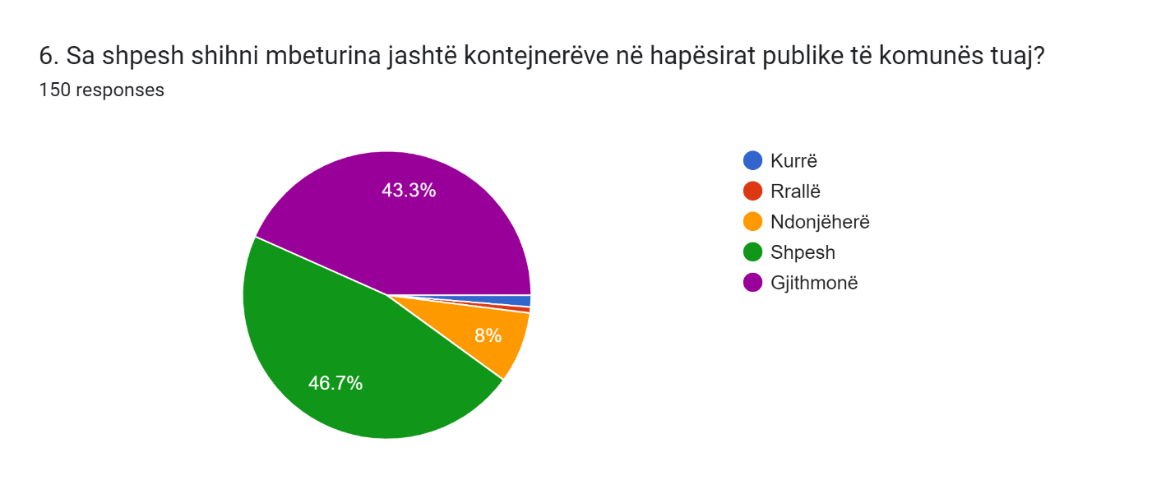
In order to collect data on citizens' experiences as witnesses of littering, respondents were also invited to describe these experiences in an open-ended question. Of the 93 who responded, the most frequent accounts included:
Businesses overloading neighborhood containers; Construction site debris; Citizens disposing of household waste in street bins; Individuals dumping inert waste in nature; Waste tossed from cars; Home renovation generated waste; Large supermarkets generating nearby waste accumulation; High-rise construction sites permanently filled with waste; Cafés generating significant waste; Disposal of waste into rivers; Waste thrown from apartment windows and outside containers/bins.
In an analogous fashion when asked to identify the urban areas most affected by illegal dumping, respondents most frequently selected: high-density residential areas (74.7%), abandoned urban spaces/zones (64.7%), and rivers (60.7%).
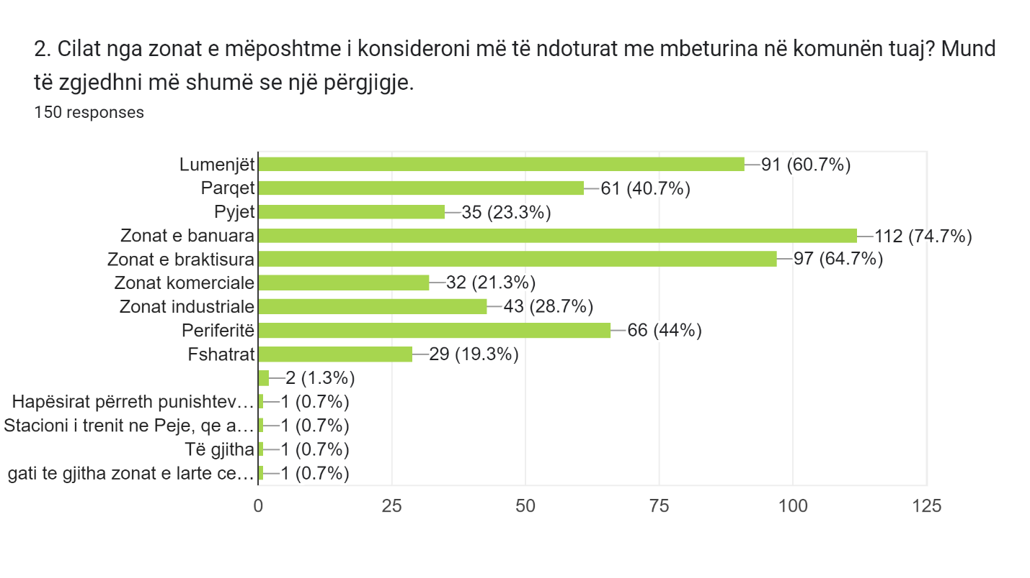
To assess the effectiveness of legal instruments preventing illegal dumping, respondents were asked about their experiences with fines. Only 2.7% reported knowing of a business or individual that had been fined. This minimal figure, contrasted with the very high percentage of citizens witnessing illegal dumping, highlights a significant lack of enforcement of the “polluter pays” principle.
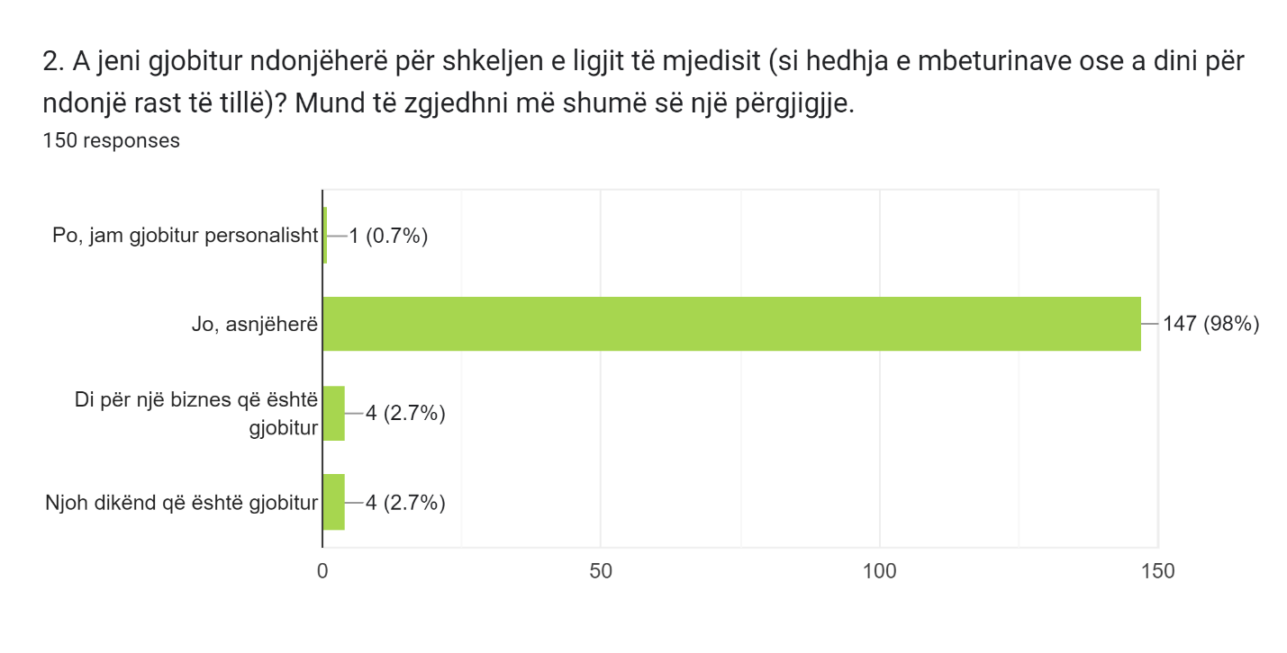

6.3.1.1 Public Perception of the Impacts of Waste on the Environment and the Performance of Responsible Institutions
Another set of questions measured citizens’ perceptions of waste management, environmental protection, and satisfaction with government institutions’ enforcement of environmental law.
According to the data collected from respondents three dominant challenges related to the presence of waste in their neighborhood emerged, namely: lack of recycling containers/bins (68%), poor waste management (60.7%), and inadequate maintenance (47.3%).
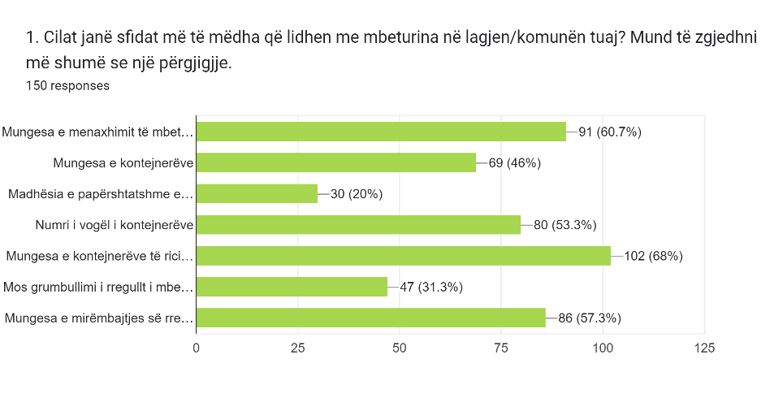
Regarding government engagement collected data reveal that 58.7% of respondents stated that the government has done little, while 38% said it has done nothing at all. Only 2.7% of respondents believed that government efforts were sufficient in protecting the environment from waste pollution. Respondents identified several causes for illegal dumping: lack of public awareness and education (60%), insufficient law enforcement (51.3%), and inadequate infrastructure for waste management (44%).
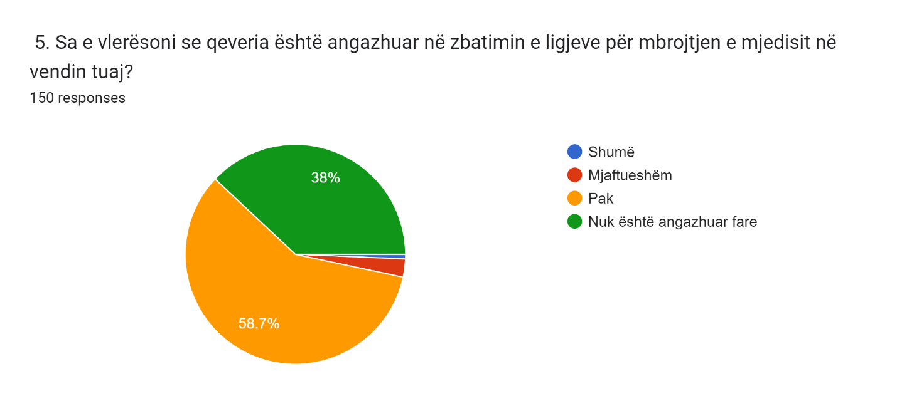

Respondents identified several causes for illegal dumping such as: lack of public awareness and education (60%), insufficient law enforcement (51.3%), and inadequate infrastructure for waste management (44%).
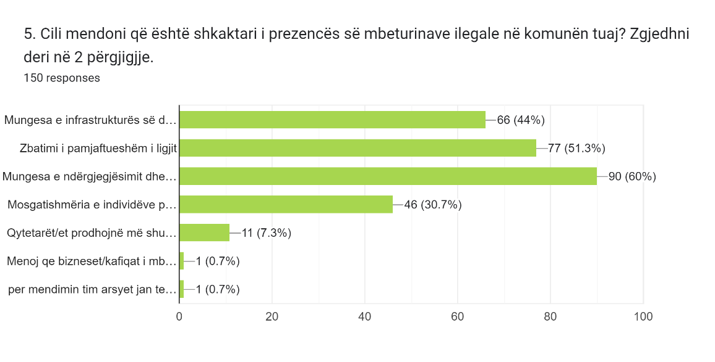
Apropos of perception why the government has done little to protect the environment, respondents raised several concerns, namely: insufficient penalization of polluters (78.7%), lack of promotion of environmental laws and sanctions (69.3%), insufficient investment in environmental protection (68%), and government favoritism toward businesses over the environment (42.7%).
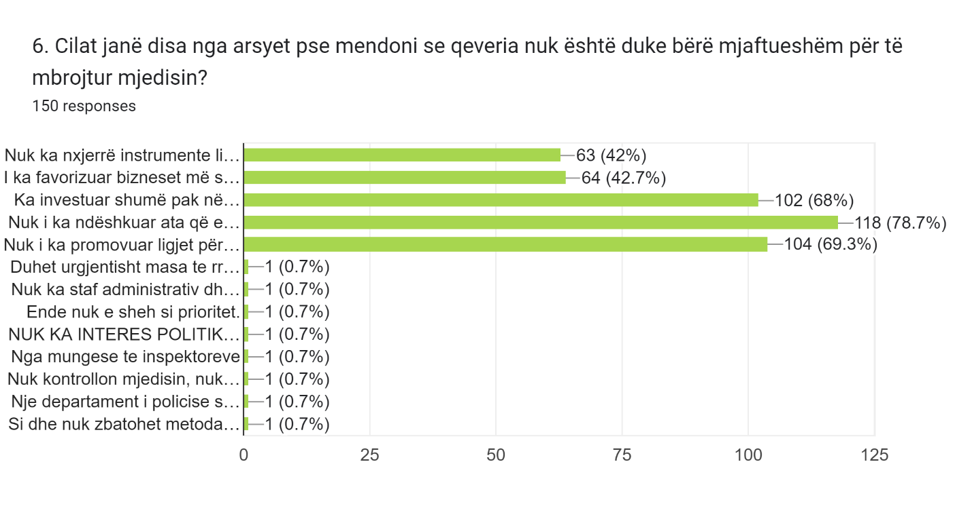
6.3.2 Public Practices of Reporting, Recycling, and Reusing Waste
This set of questions seeks to understand respondents’ behavior related to reporting illegal dumping, recycling, and reuse practices, as well as acquisition of knowledge about the participants’ eventual actions when encountering such behaviors.
6.3.2.1 Illegal Dumping Reporting Practices

A substantial majority (81.3%) stated that they had never reported illegal dumping. This suggests a lack of active citizen engagement in reporting violations, which may stem from unawareness of reporting channels, perceived inefficiency, or distrust in authorities’ response. Further research is needed to understand the factors contributing to citizens’ reluctance to report illegal dumping. This aligns with focus group findings, where participants also reported not knowing how or where to report such incidents namely violations.
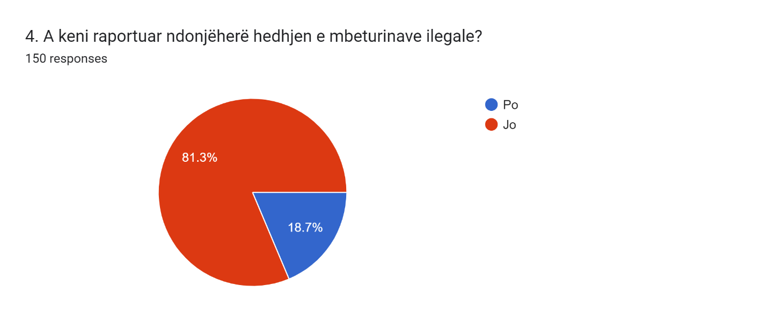

6.3.2.2 Recycling and Reuse Practices
With respect to recycling behavior and knowledge, the responses provide some interesting insights. Only 22% of participants stated that they actively recycle and reuse items. This suggests that a relatively small proportion of the community is engaged in recycling practices. The finding may reflect a lack of awareness or motivation among respondents to participate in recycling initiatives. The low number of respondents who recycle may also be linked to the fact that 89.3% reported the absence of recycling containers/bins in their neighborhoods.
Additionally, 24.7% of respondents expressed willingness to recycle but reported lacking knowledge on how to do so. This revelation highlights the importance of providing accessible information and resources on recycling practices.
By the same token a significant share of respondents (42.7%) also noted that they do not know where to take waste for recycling. This points to the need for improved waste management infrastructure and clearer guidance on recycling procedures. It suggests that the absence of accessible recycling facilities and information on collection points may be hindering recycling processes within the community. Finally, 10.7% of respondents stated that they neither recycle nor reuse items they no longer need.
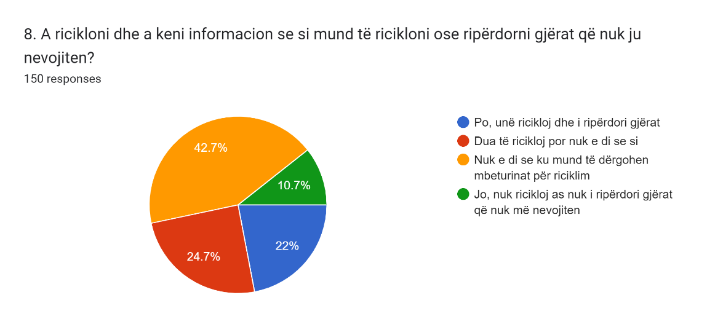

Overall, the analysis of these questions provides insight into behavioral and knowledge gaps related to reporting illegal dumping and recycling.
6.3.3 Public Awareness: Environmental Legislation, Plastic Waste and Microplastics
This group of questions aimed to assess respondents’ knowledge of environmental legislation, illegal dumping, plastic waste, microplastics, and the actions required when encountering illegal waste.
6.3.3.1 What is Illegal Waste?
In terms of knowledge about illegal waste, respondents demonstrated varying levels of understanding. A majority (71.3%) identified waste disposed of outside containers as illegal waste. In addition, a significant proportion (67.3%) recognized toxic waste and construction waste as forms of illegal waste. However, only 43.3% associated plastic waste with illegality. This suggests a possible knowledge gap regarding the unlawful nature of improper plastic disposal.
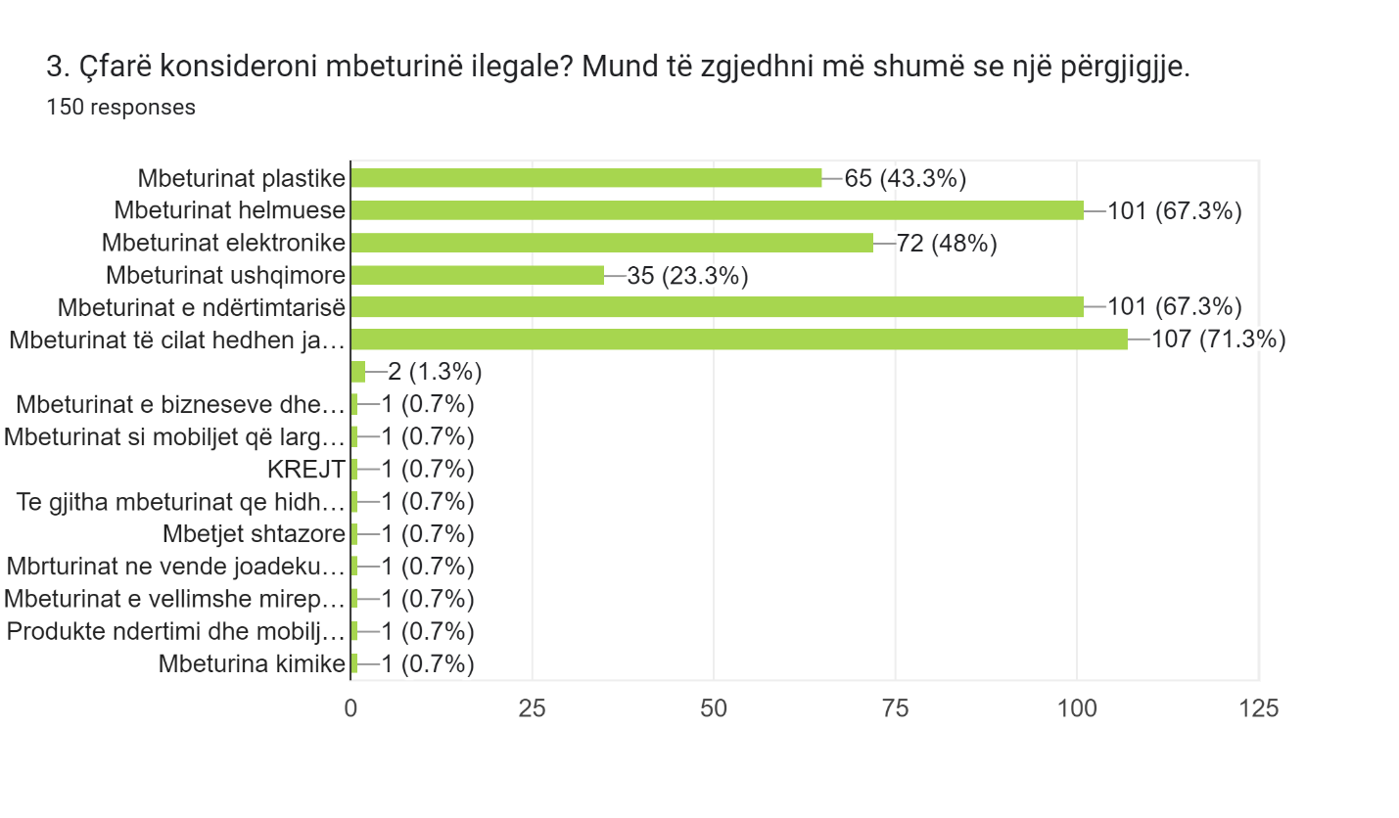6.3.3.2 Where Should Illegal Dumping be Reported when Encountered?
In terms of dealing with illegal dumping and identifying the responsible institution and actions that should be taken, respondents showed different levels of knowledge. Only 27.3% of participants said they knew what actions to take and recognized the responsible institution for dealing with illegal waste. This indicates that a relatively small portion of the community is both informed and prepared to address such situations. In addition, 22% reported knowing what actions should be taken but were uncertain about which institution was responsible. This finding highlights the need for clearer communication and dissemination of information about the authorities or organizations to contact when encountering illegal dumping.
Notably, a considerable proportion of respondents (42%) stated that they neither knew what actions to take nor which institution was responsible. This reveals a serious knowledge gap within the community and underscores the need for comprehensive awareness campaigns, educational programs, and accessible information regarding the appropriate responses and responsible authorities for addressing illegal dumping when encountering such actions.
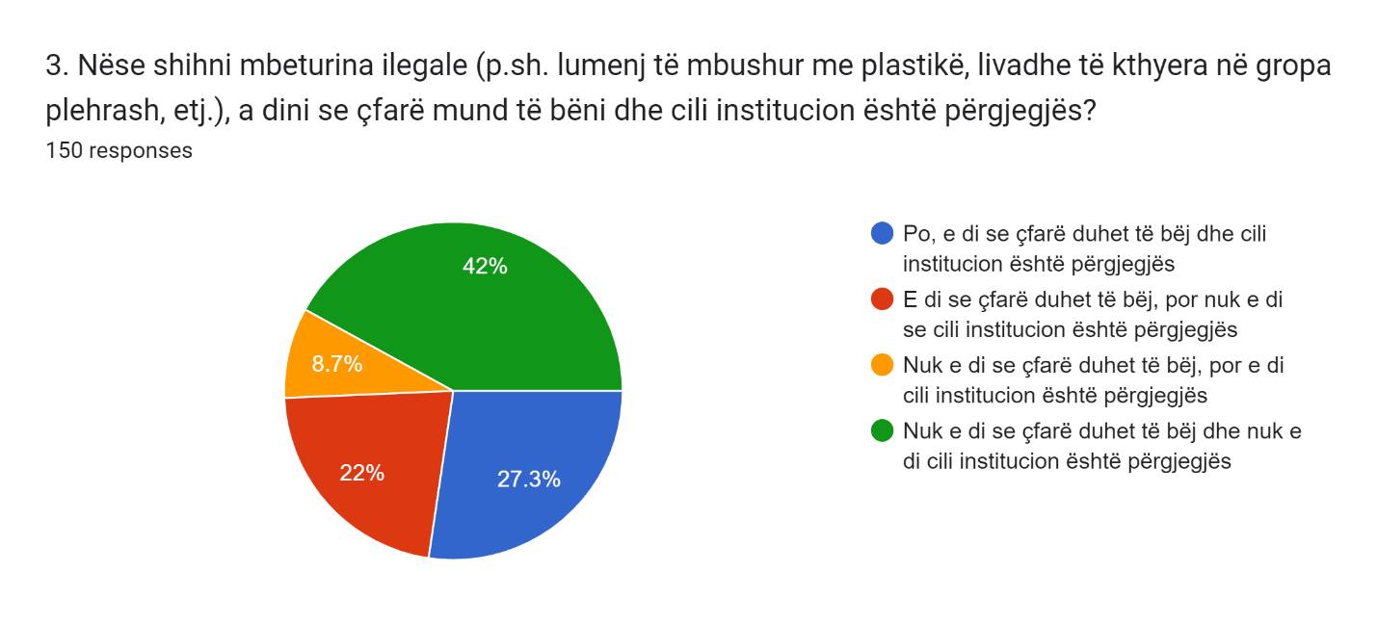
6.3.3.3 What is Plastic Waste?
With respect to perceptions of plastic waste, the vast majority of respondents (90%) considered it harmful. This finding aligns with growing awareness of the environmental impact of plastic pollution and its negative effects on ecosystems, wildlife, and human health. However, it is noteworthy that 20% of respondents perceived plastic waste as unavoidable. This perception highlights the need for further education to promote understanding that reducing plastic consumption and adopting sustainable alternatives can help mitigate the negative consequences associated with plastic waste.
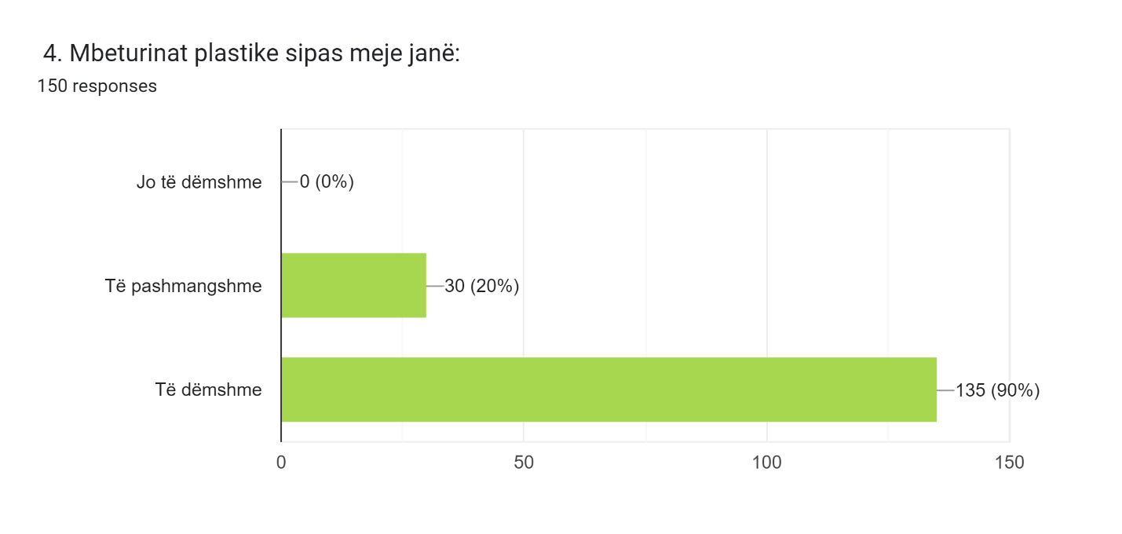

6.3.3.4 Public Awareness about Microplastics
In terms of familiarity with microplastics, 66.7% of respondents reported having heard of the term. This suggests a moderate level of awareness about the presence and impact of microplastics in the environment. However, it is noteworthy that one-third of respondents (33.3%) stated that they had never heard of microplastics. This finding highlights the need for further education and awareness campaigns to ensure broader understanding of this environmental issue. Correspondingly, during public meetings, citizens generally admitted to having limited knowledge about microplastics.
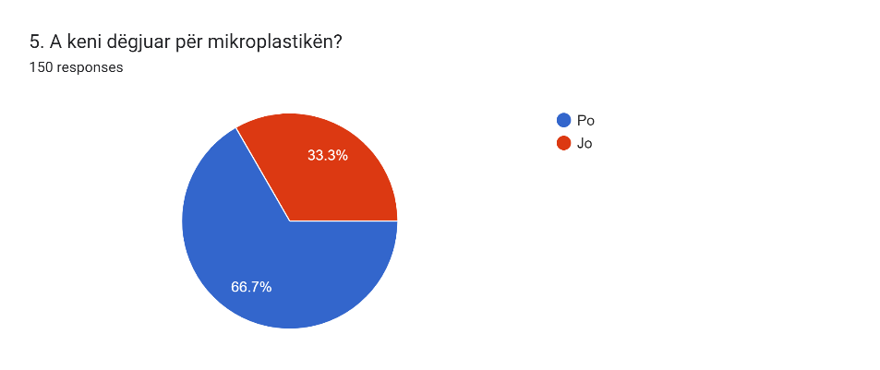
6.3.3.5 How Informed Are Respondents About Environmental Legislation?
When asked about receiving information on environmental protection laws, responses varied. A significant proportion (29.3%) stated that they had never received any information on such laws. This suggests a potential lack of awareness or communication regarding environmental regulations within a substantial portion of the community. However, 34% reported receiving information rarely, while an additional 23.3% stated that they sometimes receive information. This indicates that efforts are being made to disseminate information on environmental protection laws, though there remains room for improvement in terms of frequency and effectiveness. Overall, the findings show that participants had very limited knowledge of environmental legislation.
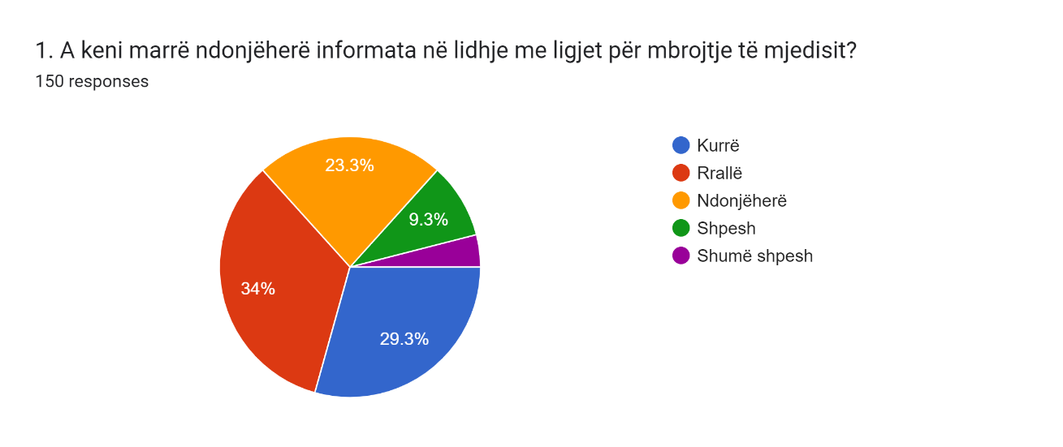

6.3.4 Public perception and attitudes towards plastic waste and illegal dumping
Responses to the questions designed to measure citizens’ beliefs and attitudes toward plastic waste and its impact on health demonstrate high levels of awareness and concern.
These questions sought to collect data on various aspects of respondents’ beliefs and attitudes, including: Concerns and awareness about environmental issues related to plastic waste pollution; The environmental impact of plastic; Personal concerns about the impact of plastic on their own health; Their sense of urgency regarding the need to address plastic waste.
Findings from the questionnaire reveal that most respondents expressed a high level of concern about the impact of plastic waste on the environment. This high level of concern can be interpreted as a positive indicator of citizens’ awareness of plastic pollution. The vast majority of respondents (94.7%) stated that they believe plastic waste poses a serious health problem. Furthermore, 80% reported that the risk of plastic pollution to their health is a major concern. These responses reflect widespread concern among citizens for both environmental and personal health impacts of plastic pollution. In addition, an absolute majority of respondents agreed that plastic waste in the environment should be treated as an urgent issue.
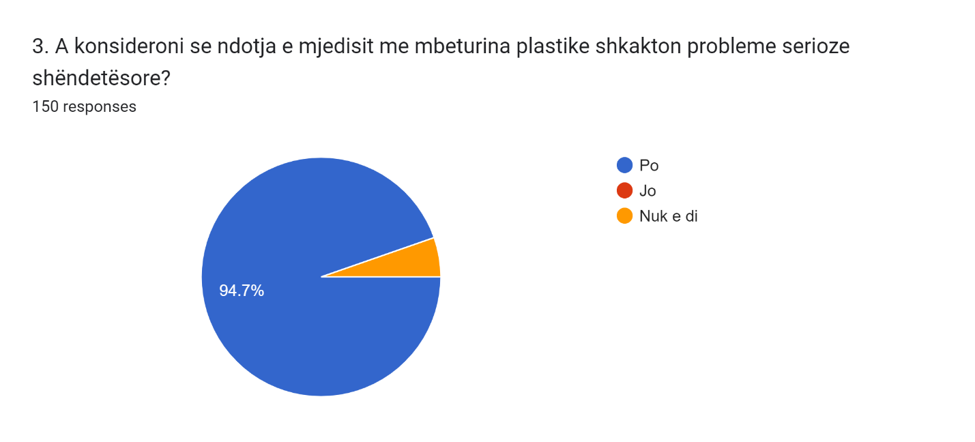
6.4 Summary of Findings
The analysis of data collected through the questionnaire confirms the serious environmental situation in Kosovo caused by waste—particularly plastic waste—as well as the lack of implementation of legal instruments to prevent and manage this phenomenon.
In this regard, s vast majority of respondents (90%) observed significant levels of illegal dumping. Only a very small proportion (2.7%) reported being aware of fines issued to natural or legal persons for violations of waste management laws.
- Waste-related challenges: Respondents identified several challenges in waste management within their neighborhoods or municipalities, including lack of recycling containers/bins, insufficient waste management infrastructure, and poor maintenance.
- Pollution hotspots:.The most polluted areas in municipalities, according to respondents, were residential zones, abandoned areas, and rivers. This highlights the need for targeted efforts to address waste accumulation and pollution in these locations.
- Causes of illegal dumping: Illegal dumping was attributed to factors such as lack of public awareness and education about proper disposal, insufficient law enforcement, and inadequate waste management infrastructure.
- Behavioral factors: Most respondents had not reported illegal dumping, suggesting a lack of proactive citizen engagement in addressing environmental violations. Moreover, a considerable proportion also expressed a lack of knowledge about recycling and waste disposal, underscoring the need for educational and awareness campaigns.
- Knowledge gaps: Respondents demonstrated a general understanding of what constitutes illegal waste and some awareness of microplastics. However, they showed limited knowledge about appropriate actions to take and the responsible institutions when encountering illegal dumping. This suggests a need for clearer guidance and information dissemination.
- Health risks from plastic: A particularly striking finding is that an overwhelming majority of respondents ( 94.7%) stated that they consider plastic waste to pose serious health risks. Notably, none of the respondents said plastic was harmless. This underscores the importance of the issue, as citizens recognize the potential health dangers associated with plastic pollution.
- Government engagement: Respondents expressed mixed perceptions of government commitment to enforcing environmental laws. While some believed the government was somewhat engaged, a significant portion expressed skepticism, perceiving insufficient action taken by the government.
- Government efforts on environmental protection: Many respondents believed that government efforts were inadequate, citing factors such as limited pressure on polluters, lack of promotion of environmental laws and punitive measures, and insufficient investment in environmental protection initiatives.

7. RECOMMENDATIONS

Since the problems related to waste generation and management are myriad, addressing them requires an immediate transformation of the waste management system. This implies strengthening financial and human capacities at all levels of governance. Below are several recommendations that could be readily applicable and would contribute to efforts aimed at improving the waste management sector in Kosovo.
The recommendations presented here aim to contribute to creating solutions that reduce the amount of waste produced and increase the responsibility of its generators—particularly businesses, as direct or indirect producers of waste through their products.

- Drafting and Adoption of an Administrative Instruction on the Prevention and Reduction of Plastic Waste, with a Focus on Single-Use Plastics
Drafting and adopting an Administrative Instruction for the prevention and reduction of single-use plastics is a necessary step that Kosovo must take to protect the environment. This AI should introduce measures to limit the use of single-use plastics, promote sustainable alternatives, and encourage products made of recyclable materials. Immediate action should be taken to ban items such as plastic bags, bottles, straws, disposable containers, and other products that are most commonly found as litter in nature.

- Introducing a Rigorous Taxation System for Producers of Plastic Products and Importers of Plastic Materials
Introducing a rigorous taxation system for producers of plastic products and importers of plastic materials, such as packaging and wrappers, is a key recommendation for Kosovo. Such a policy would increase the cost of importing plastic products, encouraging importers to make more responsible decisions in choosing alternative, sustainable, and recyclable materials.
This would contribute to reducing plastic use, decreasing pollution and the spread of plastic waste in the environment, and promoting sustainable practices in the production and trade of goods. Similarly, domestic producers of plastic products should also be subject to strict taxation, ensuring that the system functions as a measure to prevent the production of plastic products, especially single-use items.

- Establishing a Legal Framework for a “Pay as You Throw” Scheme, with a Focus on Commercial Waste
Kosovo should develop and implement a legal infrastructure and comprehensive mechanisms to establish a “Pay as You Throw” waste billing scheme, with special emphasis on businesses. This scheme should include fees for waste collection from businesses based on the quantity of waste they generate, serving as a strong incentive to encourage waste reduction, recycling efforts, and environmentally friendly packaging practices. For household waste, such a scheme would not only distribute responsibility by charging higher fees to the largest waste producers, concurrently it could also serve as an incentive for households to reduce their waste generation.

- Assigning Greater Responsibility to Businesses for Waste Collection and Disposal
According to the survey results conducted as part of this research, citizens perceive businesses as among the largest contributors to waste dumped outside containers, with businesses overloading containers that, in their view, should primarily serve household waste. To address this issue, we recommend assigning businesses the responsibility for managing and disposing of their own waste. It is vital to develop and enforce a legal framework requiring businesses to take responsibility for appropriately handling their waste in compliance with environmental standards. In this regard, businesses should be required to draft waste management plans that specify the quantity, type, and method of disposal of their waste.

- Implementing and Managing Infrastructure for Waste Separation at Source, Supported by Incentive Policies

Implementing infrastructure and policies for waste separation at source in Kosovo is essential for promoting responsible waste treatment namely management. This infrastructure should include separate containers for different types of materials and facilities for their processing, in order to reduce the volume of waste ending up in landfills. Additionally, to encourage waste separation and citizen participation, incentive policies should be introduced. These could include tax reductions for companies that recycle their waste, financial incentives for individuals and households that practice waste separation, and widespread public awareness campaigns on the importance of separating waste at source.

- Promoting Sustainable Practices Through Awareness Campaigns on Reducing Waste Generation Across All Sectors

The volume of waste generated by all sectors in Kosovo is continuously increasing. To address this challenge, it is important for government institutions to take deliberate steps to promote and encourage environmentally responsible behavior, with the goal of reducing the amount of waste produced.
This requires the development of comprehensive awareness campaigns that include measures such as early environmental education for children in schools, awareness campaigns through media outlets, and the involvement of political actors in addressing this issue within public debate.
The lack of reliable data on the state of waste in Kosovo represents a serious obstacle to assessing its impact on the environment and human health. In the same token, due to the absence of available data on plastic waste and its generators, it is currently impossible to assess the specific environmental and health impacts of plastic in Kosovo.
To ensure that waste management challenges are addressed through data-driven measures, Kosovo must place greater emphasis on collecting and reporting waste-related data—especially for types of waste that pose high health risks, such as plastic. This entails stricter monitoring of waste generation, its types, and its effects on the environment, while simultaneously prioritizing environmental issues by central and local institutions, as well as by the citizens themselves.

The translation of this publication was produced with the financial support of the European Union and Open Society Foundation. Its contents are the sole responsibility of NGO DYVÓ and do not necessarily reflect the views of the donors.

Public Health and Environment.World Health Organization. https://www.who.int/data/gho/data/themes/public-health-and-environment (Viewed on: May 23, 2023).
Ibid.
Plastic waste management: Plastics and the Environment Series. (2023). https://www.genevaenvironmentnetwork.org/resources/updates/plastic-waste-management. (Viewed on: May 23, 2023)
Roland Geyer et al. Production, use, and fate of all plastics ever made.Sci.Adv.3,e1700782(2017). DOI:10.1126/sciadv.1700782
Leslie, H. M., Van Velzen, M., Brandsma, S. H., Vethaak, D., Garcia-Vallejo, J. J., & Lamoree, M. H. (2022). Discovery and quantification of plastic particle pollution in human blood. Environment International, Volume 163
Yu J.R., Adingo S., Liu X.L., Li X.D., Sun J., Zhang X.N. (2022): Micro plastics in soil ecosystem – A review of sources, fate, and ecological impact. Plant Soil Environ., 68: 1–17.
Johnny Gasperi, Stephanie L. Wright, Rachid Dris, France Collard, Corinne Mandin, Mohamed Guerrouache, Valérie Langlois, Frank J. Kelly, Bruno Tassin,Microplastics in air: Are we breathing it in?,Current Opinion in Environmental Science & Health, Volume 1,2018, Pages 1-5, ISSN 2468-5844, https://doi.org/10.1016/j.coesh.2017.10.002.
Janice Brahney et al., Plastic rain in protected areas of the UnitedStates.Science368, 1257-1260(2020). DOI:10.1126/science.aaz5819
World Health Organization. (2019). Microplastics in drinking-water. https://www.who.int/publications/i/item/9789241516198. (Viewed on: May 25, 2023)
European Commission (2022). Kosovo* 2022.Report https://neighbourhood-enlargement.ec.europa.eu/system/files/2022-10/Kosovo%20Report%202022.pdf (Viewed on: 2023)
Ministry of Environment and Spatial Planning (2013). Kosovo Integrated Waste Management Strategy. See: https://kryeministri.rks-gov.net/wp-content/uploads/2022/07/STRATEGY-OF-THE-REPUBLIC-OF-KOSOVO-on-WASTE-MANAGEMENT.pdf.(Viewed on: 03.05.2023)
Kosovo Environmental Protection Agency (2021). Annual report on the state of the environment 2020. See: https://ammk-rks.net/assets/cms/uploads/files/Raport vjetor për gjendjen e mjedisit ANG ueb.pdf (Viewed on: 20.05.2023)
Kosovo Environmental Protection Agency (2018). Report on Environmental Indicators. See: https://ammk-rks.net/assets/cms/uploads/files/Publikime-raporte/Mjedisi_i_KosovÃ«s_2020_Raport_i_treguesve_mjedisorÃ«_-_ANGLISHT.pdf (Viewed on: 20.05.2023)
Kosovo Agency of Statistics (2021). Municipal waste survey. See: https://ask.rks-gov.net/media/6443/amk-2020.pdf (Viewed on: 20.05.2023)
European Parliament (2018) Plastic waste and recycling in the EU: facts and figures.https://www.europarl.europa.eu/news/en/headlines/society/20181212STO21610/plastic-waste-and-recycling-in-the-eu-facts-and-figure`s (Viewed on: 20.05.2023)
Ministry of Environment and Spatial Planning (2021). Strategy (2021-2030) and Action Plan (2021-2023) of Kosovo for Integrated Waste Management. See. https://gzk.rks-gov.net/ActDetail.aspx?ActID=42930 (Viewed on: 23.05.2023)
Assembly of the Republic of Kosovo (2008). Constitution of the Republic of Kosovo. See: https://gzk.rks-gov.net/ActDetail.aspx?ActID=3702 (Viewed on: 23.05.2023)
Assembly of the Republic of Kosovo (2008). Constitution of the Republic of Kosovo. See: https://gzk.rks-gov.net/ActDetail.aspx?ActID=3702 (Viewed on: 23.05.2023)
Collection of common rights and obligations that constitute the body of EU law,
European Commission (2022). Kosovo* 2022. Report https://neighbourhood-enlargement.ec.europa.eu/system/files/2022-10/Kosovo%20Report%202022.pdf (Viewed on: 2023)
Organization for Economic Co-operation and Development (2023). Extended Producer Responsibility https://www.oecd.org/environment/extended-producer-responsibility.htm. (Viewed on: 20.05.2023)
INDEP- Institute for Development Policy (2018) Waste Management in Kosovo: Identifying Challenges in the Sector. See: https://dokumen.tips/documents/menaxhimi-i-mbeturinave-n-kosov-identifikimi-i-sfidave-n-mnyr-q.html?page=6 (Viewed on 20.05.2023)
Ibid. Article 13
Ibid. Article 14
Ibid.
Ministry of Environment and Spatial Planning (2021). Strategy (2021-2030) and Action Plan (2021-2023) for Integrated Waste Management in Kosovo. See: https://gzk.rks-gov.net/ActDocumentDetail.aspx?ActID=42930
Ibid.
Lëvizja FOL (2021) The Impact of Sectoral Strategies on the Environment. See: https://levizjafol.org/wp-content/uploads/2021/03/Ndikimi-i-strategjive-sektoriale.pdf (Viewed on 20.05.2023)
Assembly of the Republic of Kosovo (2022). Law No. 02/L-30 On Waste. See: https://gzk.rks-gov.net/ActDocumentDetail.aspx?ActID=2497 (Viewed on 23.05.2023)
Municipality of Peja (2016). Regulation on waste management in the territory of the Municipality of Peja. See: https://kk.rks-gov.net/peje/wp-content/uploads/sites/24/2018/04/6-23)tRregullore-komunale-mbi-menaxhimin-e-mbeturinave-ne-Komunen-e-Pejes-Nr.06-2016.pdf (Viewed on: 23.05.2023)
Municipality of Pristina (2016). Regulation on waste management in the territory of the Municipality of Pristina (2016). See: https://gzk.rks-gov.net/ActDocumentDetail.aspx?ActID=15281 (Viewed on: 23.05.2023)
Municipality of Prizren (2016). Regulation on waste management in the territory of the Municipality of Prizren. See: https://kk.rks-gov.net/prizren/wp-content/uploads/sites/26/2021/07/Rregullore-per-Mbeturina-dt.09.06.2021.pdf (Viewed on: 23.05.2023)
Municipality of Ferizajt (2016). Regulation on waste management in the territory of the Municipality of Ferizajt. See: https://gzk.rks-gov.net/ActDetail.aspx?ActID=64098 (Viewed on: 23.05.2023)
Municipality of Mitrovica (2016). Regulation on waste management in the territory of the Municipality of Southern Mitrovica. See: https://kk.rks-gov.net/mitroviceejugut/wp-content/uploads/sites/18/2022/07/Rregullorja-Nr-02-2022-per-menaxhimin-e-mbeturinave-ne-Komunen-e-Mitrovices.pdf (Viewed on 20.04.2023)
Municipality of Gjakova (2016). Regulation on waste management in the territory of the Municipality of Gjakova. See: https://kk.rks-gov.net/gjakove/wp-content/uploads/sites/2/2021/05/Rregullore-per-menaxhimin-e-mbeturinave-ne-K.-Gjakoves-nr.11196.pdf (Viewed on: 20.04.2023)
Kosovo Customs (2021). Annual Report 2021. See: https://dogana.rks-gov.net/wp-content/uploads/2022/06/Final-Raporti-vjetor-2021.pdf (Viewed on: 23.05.2023)
Kosovo Customs. A.Stavileci. Communication by email. Document: IM4- Regular Import - Commercial Data by tariff code (HS-10) - Plastic bags 2021 - 2022. Date: 23.11.2022)
Fisnik Reçica and Gerd Meier zu Köcker (2019).The Plastics Industry Value Chain in Kosovo. See: https://mint.rks-gov.net/desk/inc/media/C4A08C2E-589F-47CB-8EC9-C0FF65E71CC3.pdf (Viewed on: 23.05.2023)
EUROSTAT (2023) Packaging waste Statistics. https://ec.europa.eu/eurostat/statistics-explained/index.php?title=Packaging_waste_statistics (Viewed on: 20.05.2023)
European Commission (2022) European Green Deal: Putting an end to wasteful packaging, boosting reuse and recycling. https://ec.europa.eu/commission/presscorner/detail/en/ip_22_7155 (Viewed on: 23.05.2023)
KEPA (2021). Report on municipal waste management in Kosovo. See. http://www.ammk-rks.net/assets/cms/uploads/files/Publikime-raporte/Report_municipal_waste_2019_ENG_version.pdf (Viewed on: 23.05.2023)
Assembly of the Republic of Kosovo (2022). Law No. 08/L-071 On amending and supplementing Law No. 04/L-060 On Waste. See: https://gzk.rks-gov.net/ActDocumentDetail.aspx?ActID=62435 (Viewed on: 23.05.2023)
Ibid.
Ministry of Environment and Spatial Planning (2021). Strategy (2021-2030) and Action Plan (2021-2023) for Integrated Waste Management in Kosovo. See: https://gzk.rks-gov.net/ActDocumentDetail.aspx?ActID=42930 (Viewed on: 23.05.2023)
Assembly of the Republic of Kosovo (2022). Law No. 08/L-071 On amending and supplementing Law No. 04/L-060 On Waste. See: https://gzk.rks-gov.net/ActDocumentDetail.aspx?ActID=62435 (Viewed on: 23.05.2023)
United Nations (2022). The Sustainable Development Goals. http://www.un.org/sustainabledevelopment/news/communications-material. (Viewed on: 24.05.2023)
European Commission (2019). New Circular Economy Action Plan. https://ec.europa.eu/environment/circular-economy/pdf/new_circular_economy_action_plan.pdf (Viewed on 24.05.2023)
European Commission (2019). A European Green Deal. https://eur-lex.europa.eu/legal-content/EN/TXT/?qid=1596443911913&uri=CELEX:52019DC0640#document2 (Viewed on: 24.05.2023)
European Commission (2018). A European Strategy for Plastics in a Circular Economy. https://eur-lex.europa.eu/legal-content/EN/TXT/?qid=1516265440535&uri=COM:2018:28:FIN (Viewed on 24.05.2023)
UN Environment Programme (2022) UN Member States adopted a resolution at the UN Environment Assembly to end plastic pollution. https://www.unep.org/news-and-stories/press-release/historic-day-campaign-beat-plastic-pollution-nations-commit-develop
European Commission (2019) Single Use Plastic https://environment.ec.europa.eu/topics/plastics/single-use-plastics_en (Viewed on 24.05.2023)
European Parliament (2015) DIRECTIVE (EU) 2015/720 OF THE EUROPEAN PARLIAMENT AND OF THE COUNCIL of 29 April 2015 amending Directive 94/62/EC as regards reducing the consumption of lightweight plastic carrier bags .https://faolex.fao.org/docs/pdf/eur182401.pdf (Viewed on 25.05.2023)
Nielsen, T., Holmberg, K., & Stripple, J. (2019). Need a bag? A review of public policies on plastic carrier bags – where, how and to what effect? Waste Management, 87, 428–440. https://pubmed.ncbi.nlm.nih.gov/31109543/ (Viewed on 25.05.2023)
Council of Ministers of the Republic of Albania (2018). Decision no. 232, dated 26.4.2018 on some amendments and additions to decision no. 177, dated 6.3.2012, of the Council of Ministers, “on packaging and related waste”: See: https://turizmi.gov.al/wp-content/uploads/2018/09/Vendim-i-KM_232_26.04.2018-e-ndryshuar-PER-AMBALAZHET-DHE-MBETJET-E-TYRE.doc (Viewed on 25.05.2023)
European Commission (2022). Environmental Implementation Review 2022 Country Report - SLOVENIA .https://eur-lex.europa.eu/legal-content/EN/TXT/PDF/?uri=CELEX:52022SC0273 (Viewed on 24.05.2023)
Avfall Sverige (2021). Swedish Waste Management. https://www.avfallsverige.se/media/lbdg3vcp/svensk_avfallshantering_2021_en.pdf (Viewed on 24.05.2023)
Zero Waste Cities (2020). Pay As You Throw. https://zerowastecities.eu/webinar/pay-as-you-throw/ (Viewed on 24.05.2023)
Bilitewski, B. (2008). Pay-as-you-throw – A tool for urban waste management. waste Management, 28(12), 2759. https://doi.org/10.1016/j.wasman.2008.08.001(Viewed on 24.05.2023)
OECD (2021). Modulated fees for extended producer responsibility schemes (EPR). https://one.oecd.org/document/ENV/wKP(2021)16/En/pdf (Viewed on 24.05.2023)
Bryman, Alan. Social Research Methods, New York: Oxford University Press, 2012, pp. 74-75

